Museum Posters
Poster No | Name | Pictures | Description
1 | Food adulteration and identification | 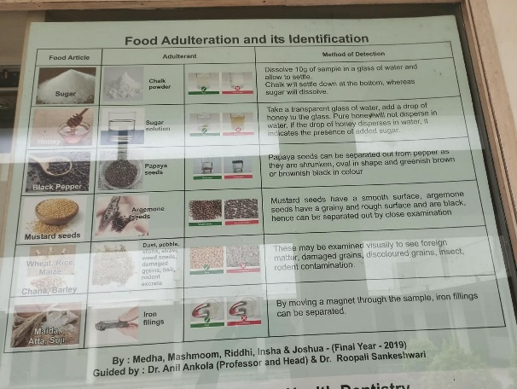  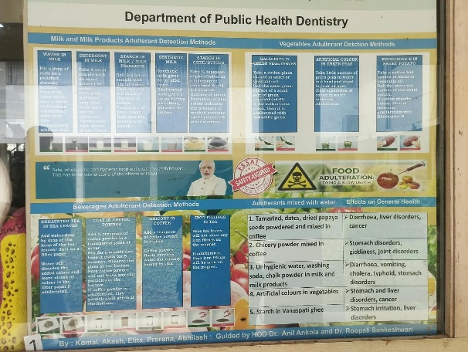 | 1. Explains common food adulterants and simple methods of identifying them.  2. Creates awareness about the health hazards associated with adulterated food.
2 | Role of plaque. Brushing the correct way |  | 1. Explains the role of dental plaque in the development of oral diseases.  2. Demonstrates the correct technique of toothbrushing for effective plaque removal.
3 | Epidemiology of oral cancer | 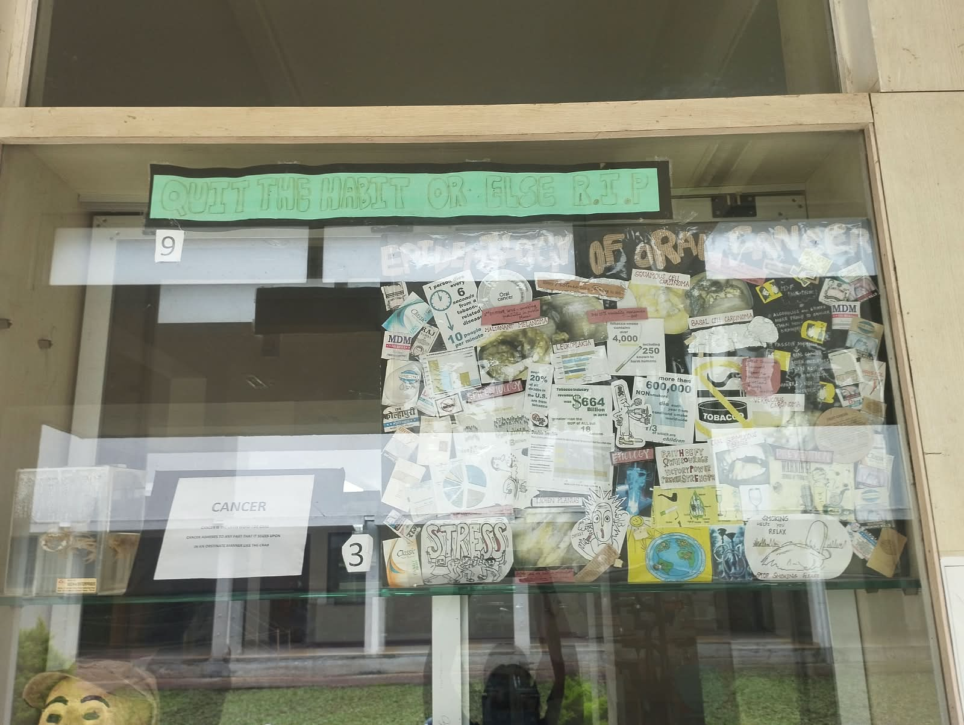 | 1. Presents the occurrence, distribution and major risk factors of oral cancer.  2. Emphasizes prevention, early detection and timely treatment of oral cancer.
4 | Periodontal disease, types of calculus | 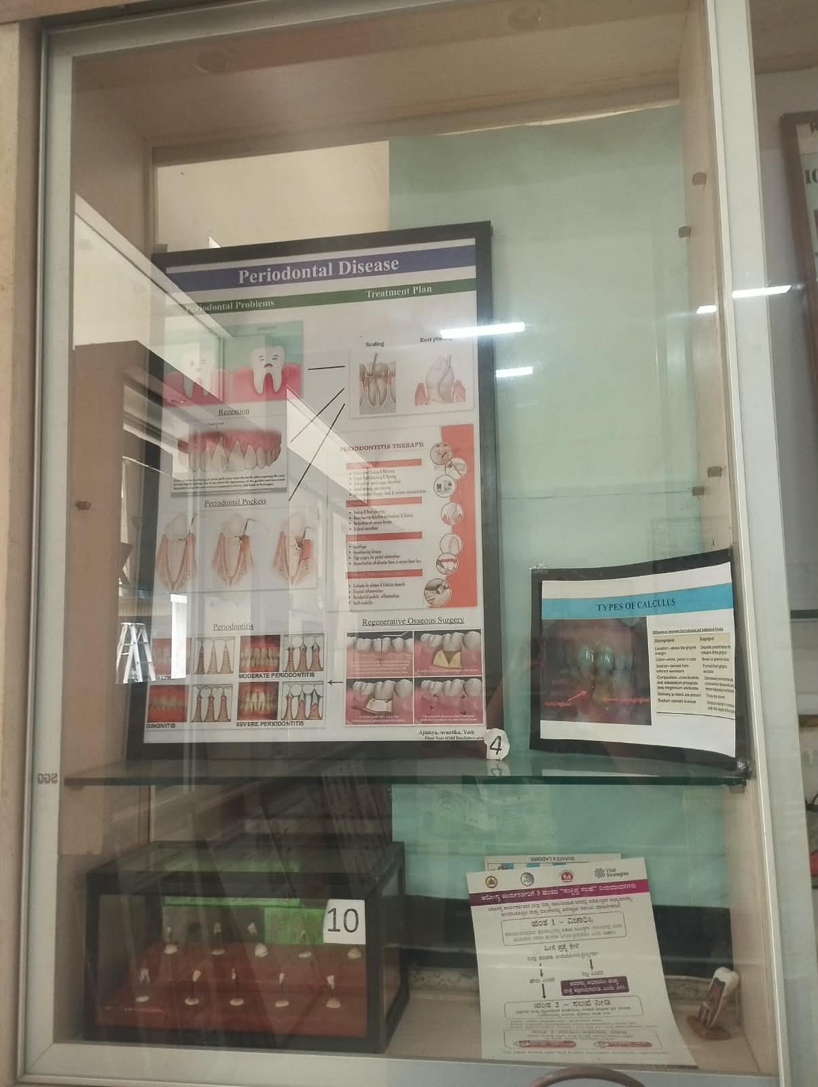  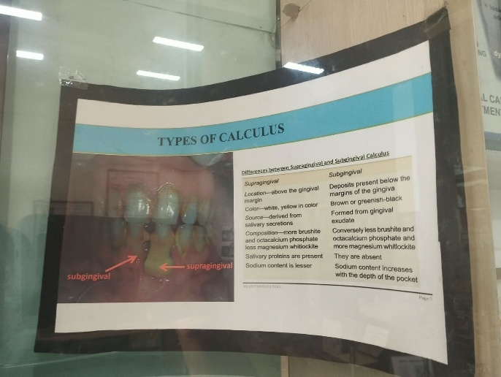 | 1. Explains periodontal diseases and the role of plaque and calculus in their development.  2. Describes the different types of dental calculus and their clinical significance.
5 | Iceberg of dental caries & treatment needs | 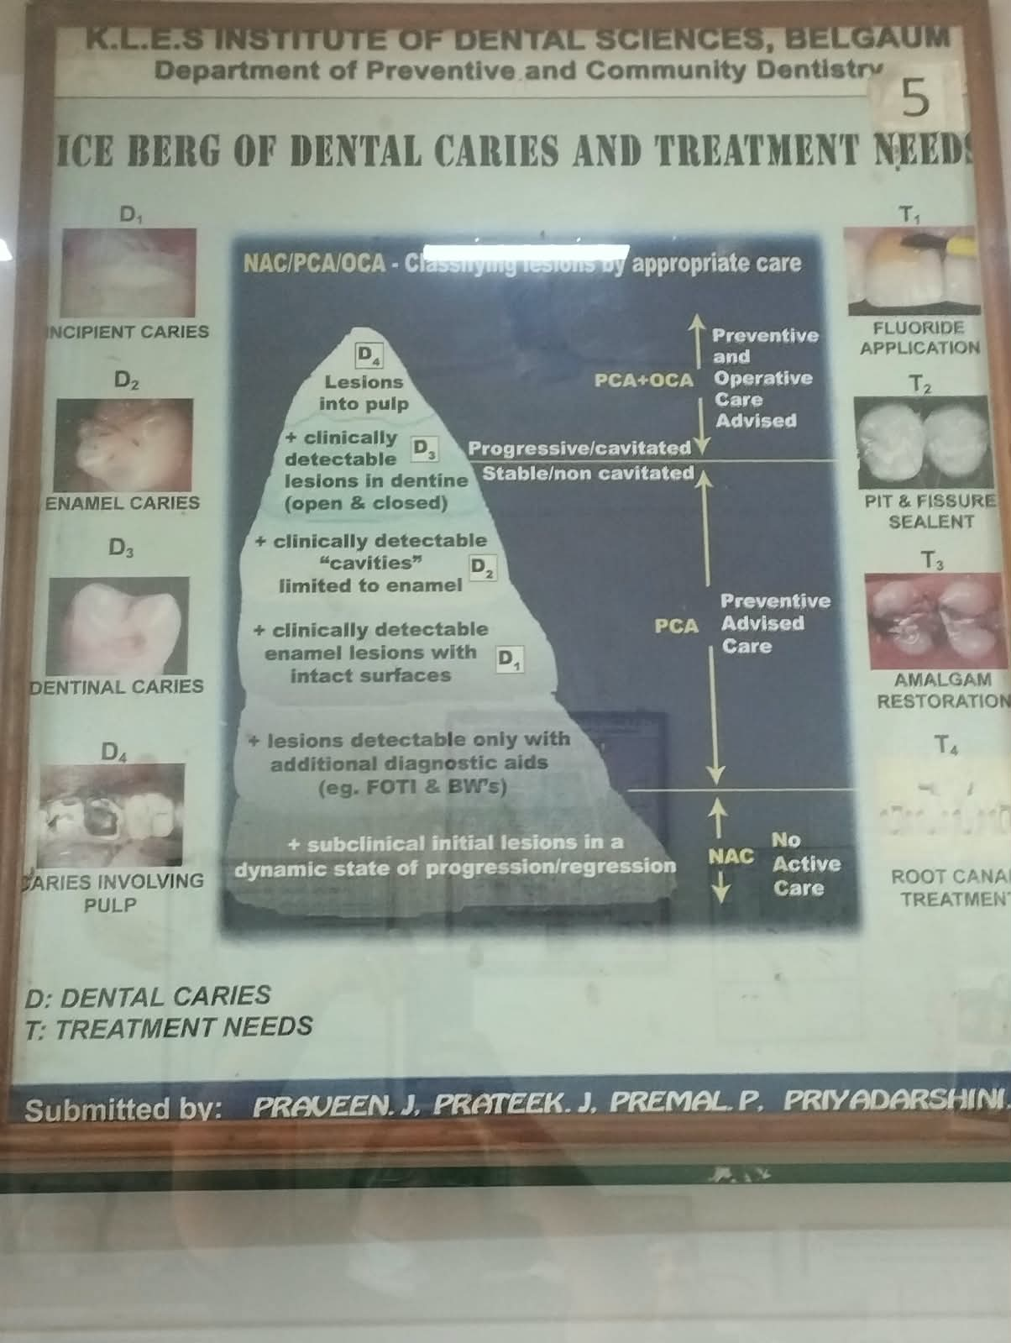 | 1. Uses the iceberg concept to illustrate the visible and hidden burden of dental caries.  2. Highlights the different treatment needs associated with dental caries in a population.
6 | Stages of tooth decay |  | 1. Illustrates the progression of dental caries from early enamel changes to advanced tooth destruction.  2. Emphasizes the importance of early identification and preventive intervention.
7 | Root canal treatment |  | 1. Explains the basic steps involved in root canal treatment of an affected tooth.  2. Shows how removal of infected pulp and sealing of the canal helps preserve the tooth.
8 | Brushing techniques, dental floss, mouthwash |  | 1. Demonstrates brushing, flossing and mouthwash use as important oral hygiene measures.  2. Promotes a comprehensive daily oral hygiene routine for maintaining oral health.
9 | Evolution of toothbrush |  | 1. Illustrates the development of the toothbrush from traditional forms to modern designs.  2. Shows how toothbrush design has evolved to improve oral hygiene and convenience.
10 | Brushing awareness |  | 1. Creates awareness about the importance of regular toothbrushing.  2. Encourages correct brushing practices as an essential part of oral hygiene.
11 | What is in a cigarette | 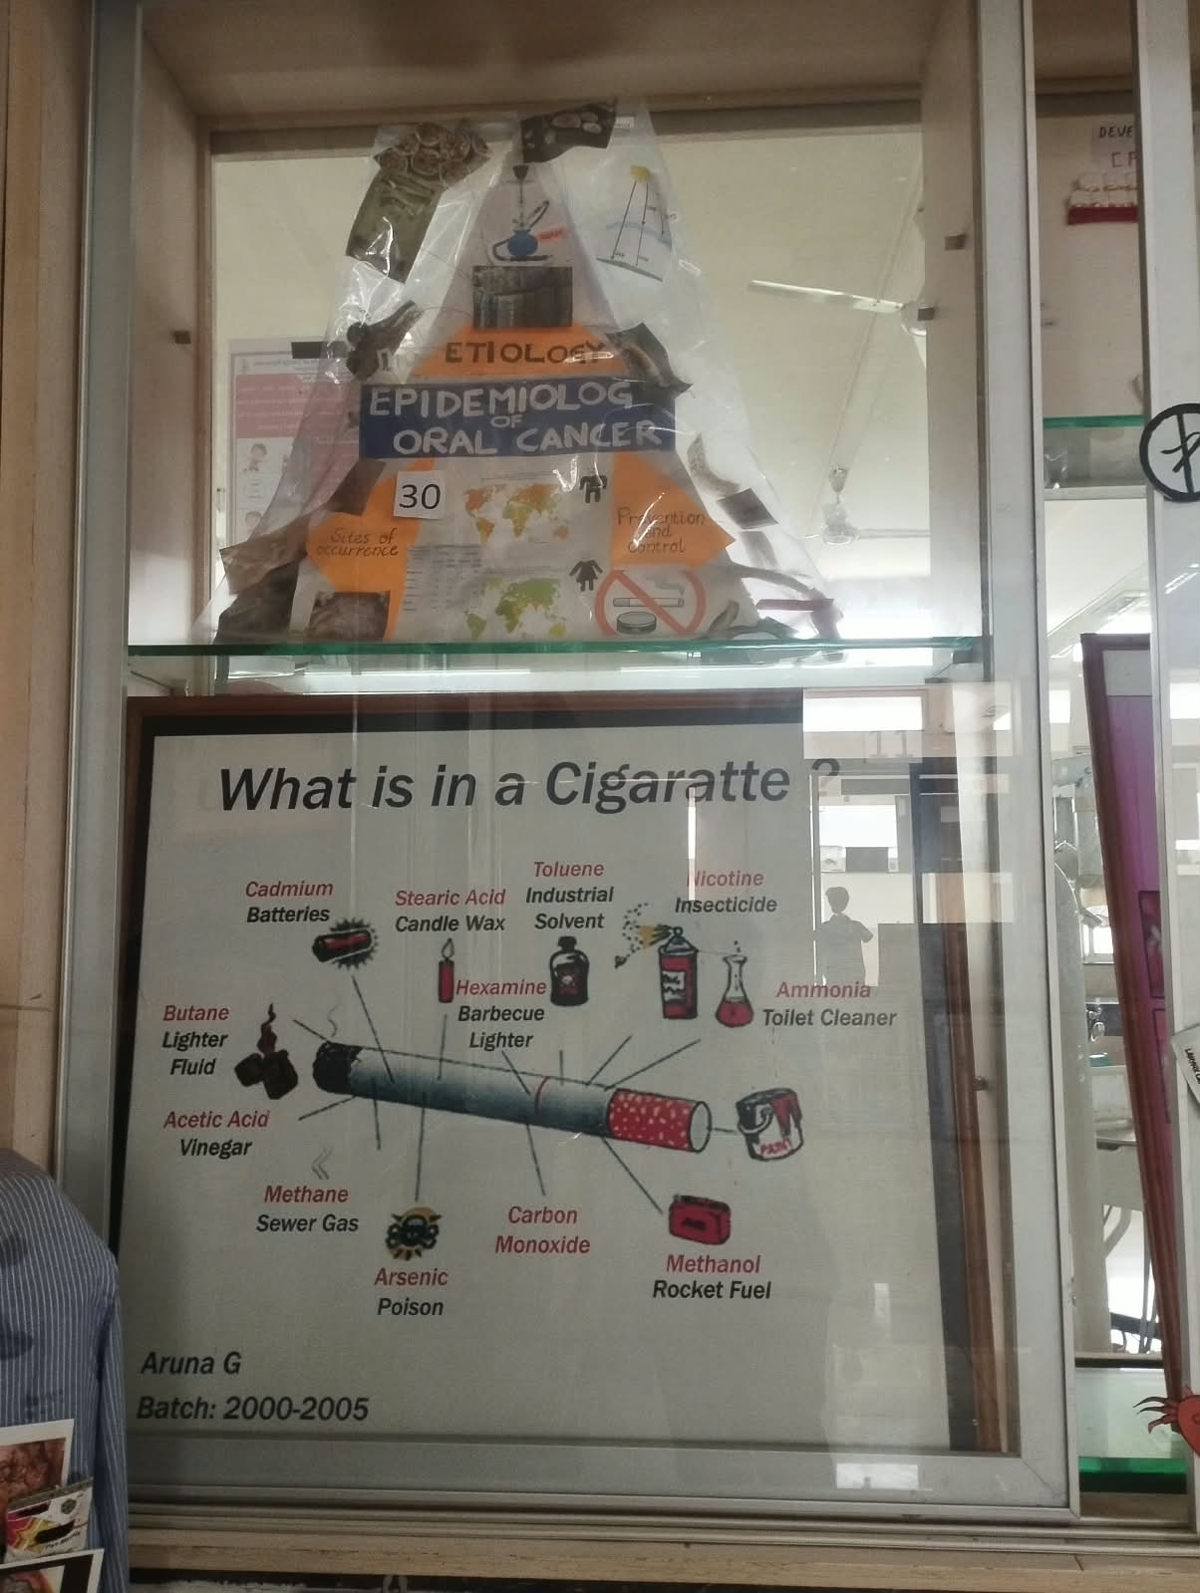 | 1. Highlights the harmful and toxic substances present in cigarette smoke.  2. Creates awareness about the addictive and damaging effects of tobacco use.
12 | Consequences of smoking in dental aspect |  | 1. Describes the harmful effects of smoking on the teeth, gums and oral tissues.  2. Emphasizes the increased risk of oral diseases associated with tobacco use.
13 | Effect of quitting smoking | 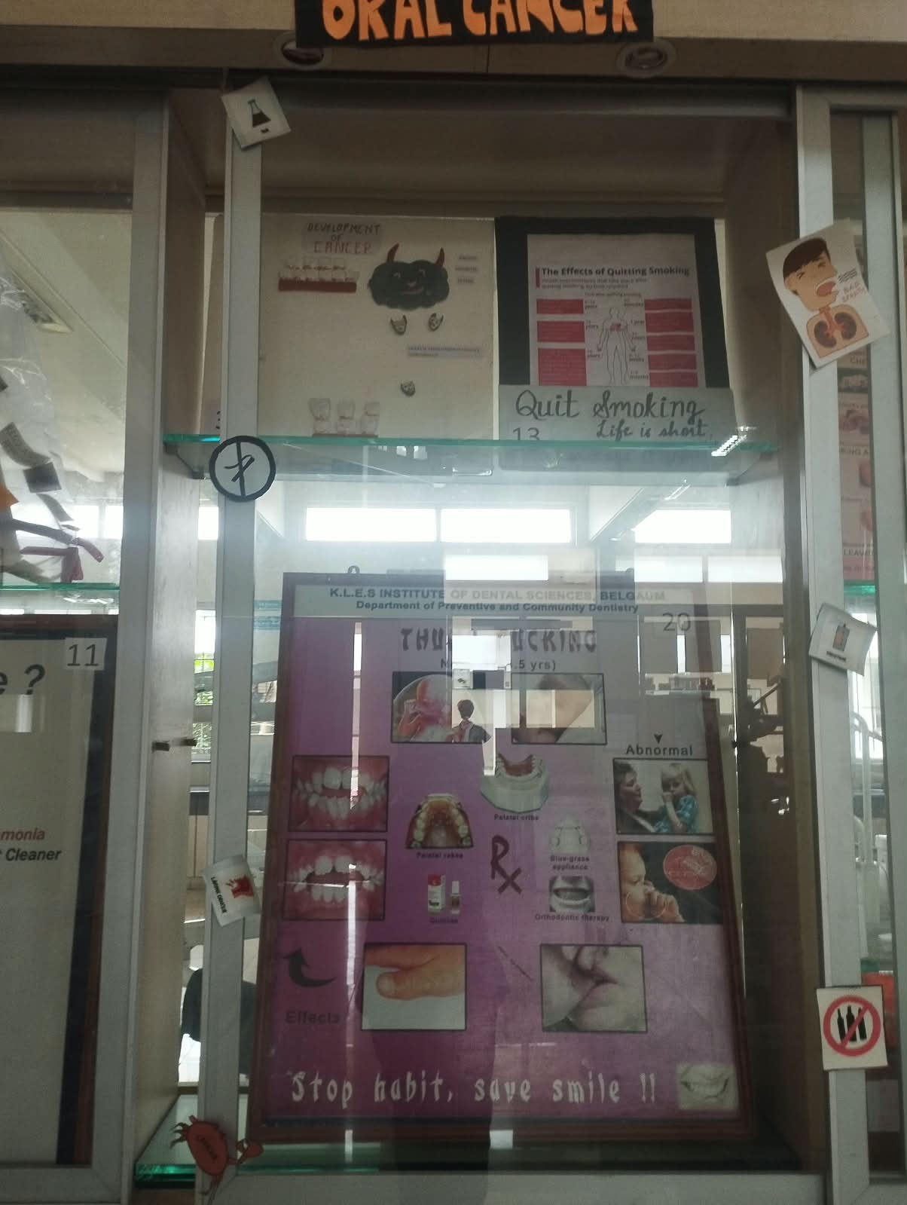 | 1. Illustrates the beneficial changes that occur after stopping smoking.  2. Encourages smokers to quit tobacco and adopt healthier habits.
14 | Tobacco thrills but kills | 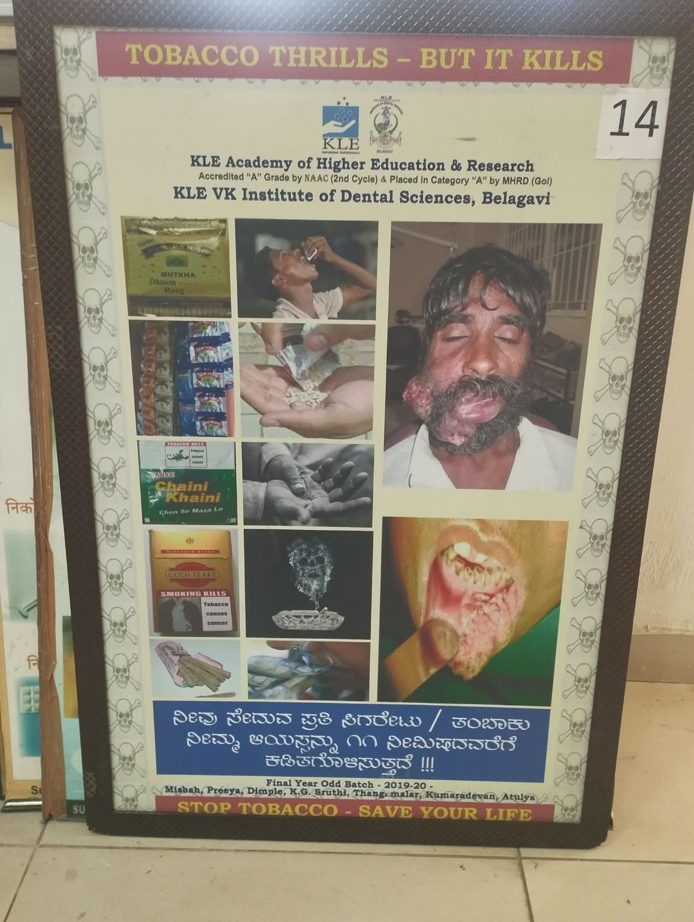 | 1. Highlights the harmful consequences of tobacco use despite its temporary pleasurable effects.  2. Promotes tobacco avoidance and cessation through health awareness.
15 | Consequences of smoking in general | 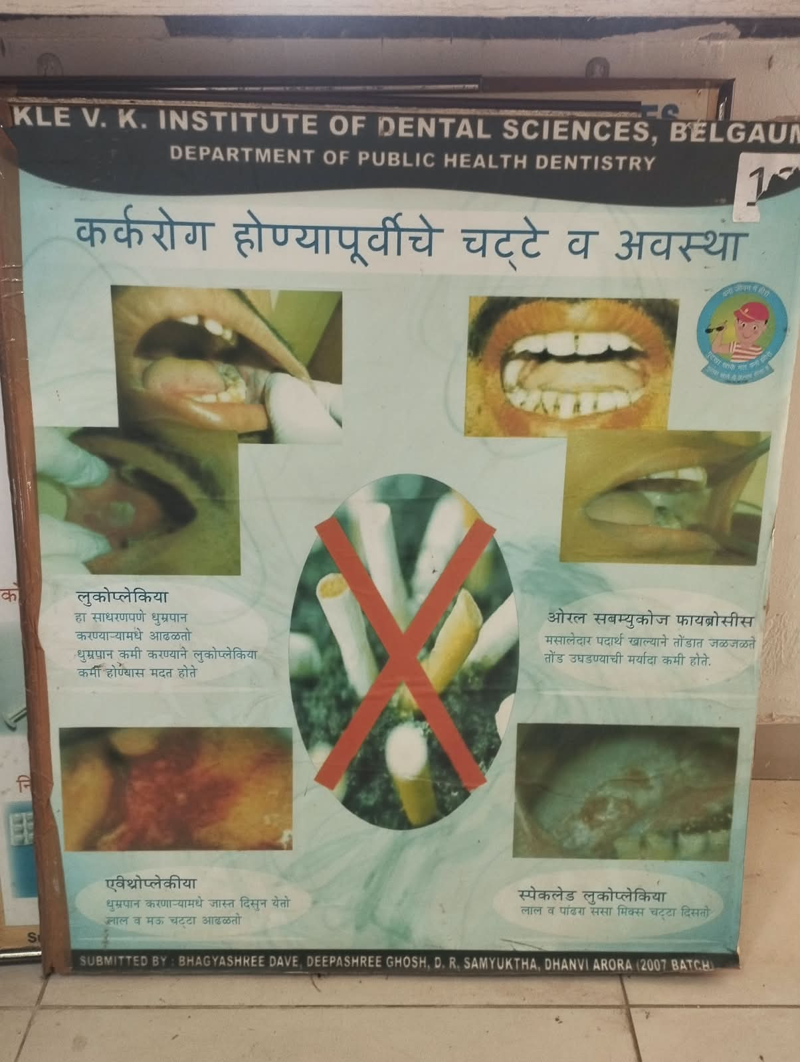 | 1. Presents the harmful effects of smoking on overall health.  2. Highlights the association of tobacco use with serious systemic diseases and premature death.
16 | Name your poison | 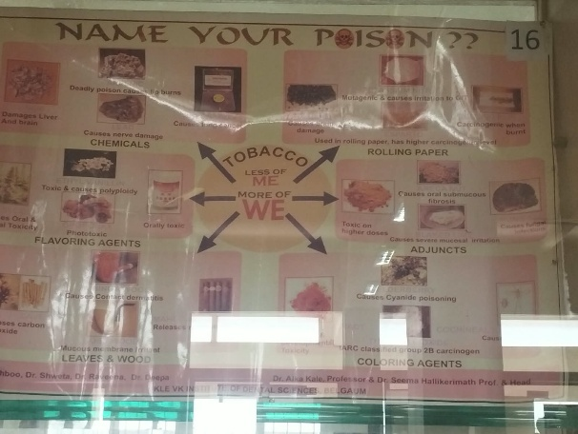 | 1. Uses an awareness message to portray tobacco as a harmful and preventable health hazard.  2. Encourages individuals to recognize the dangers associated with tobacco consumption.
17 | Awareness poster | 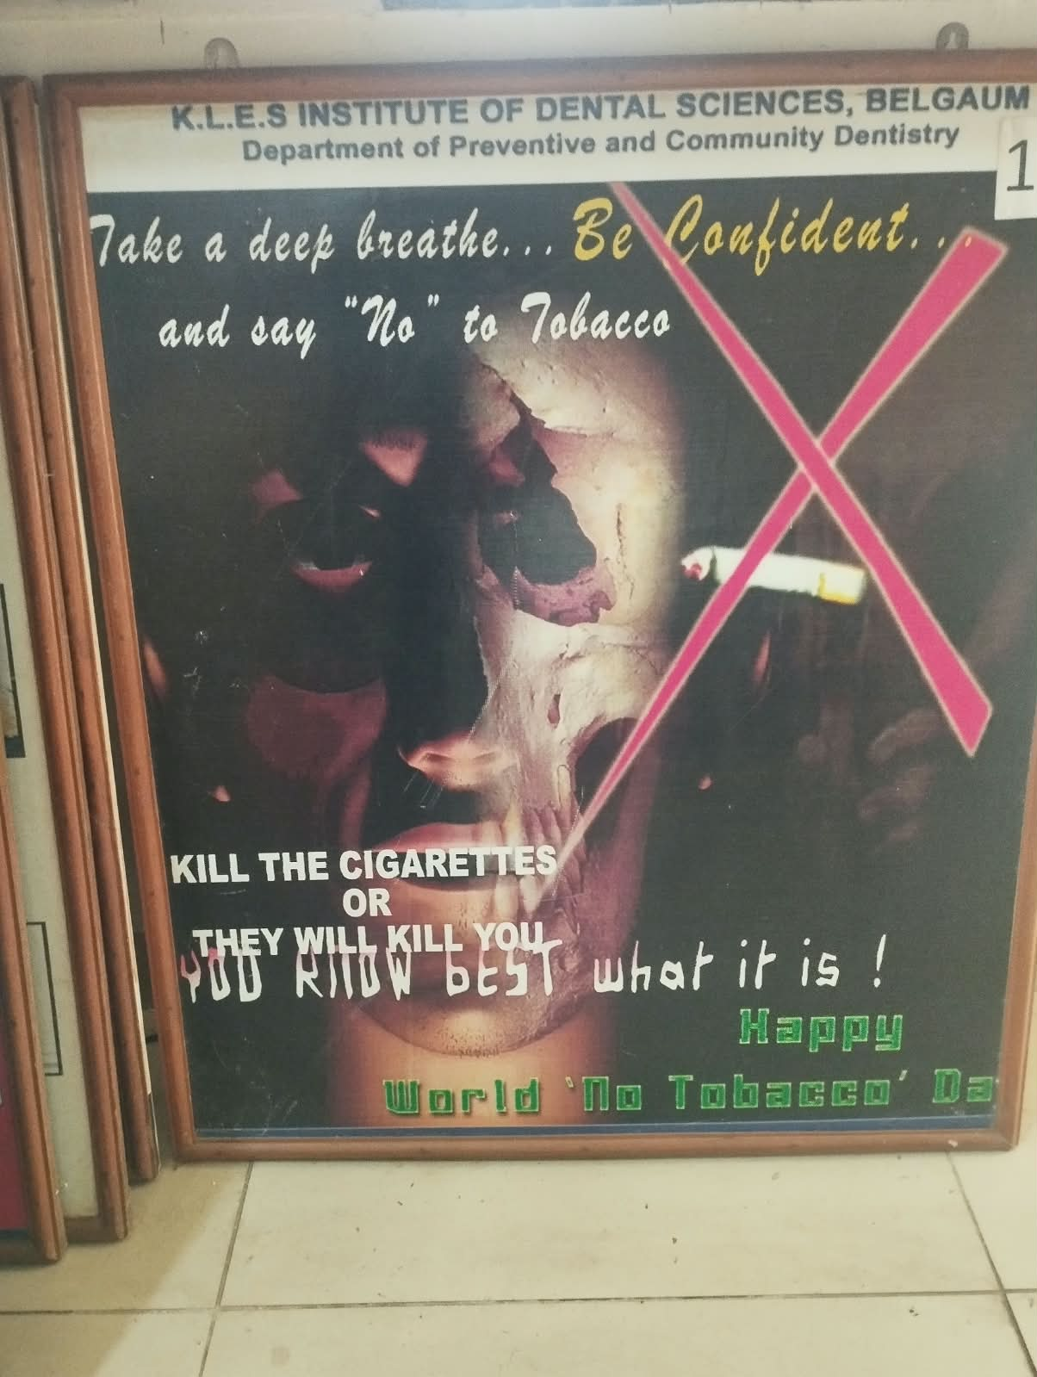 | 1. Promotes awareness about maintaining good oral health and preventing oral diseases.  2. Encourages healthy oral hygiene practices and regular dental care.
18 | Nicotine replacement therapies | 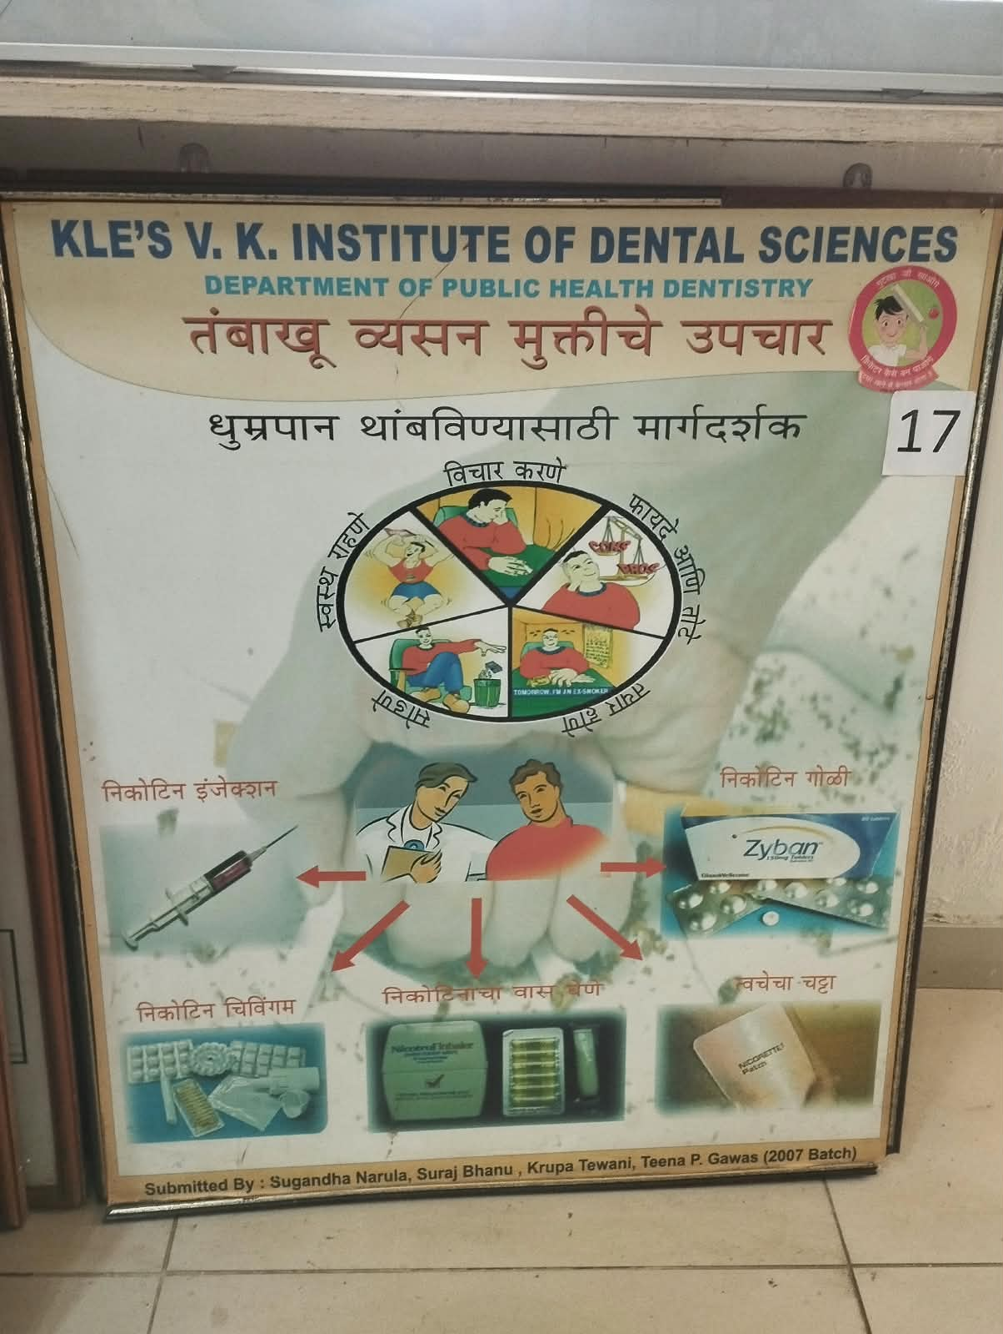 | 1. Introduces nicotine replacement therapies as aids used during tobacco cessation.  2. Explains their role in reducing nicotine withdrawal symptoms and supporting quitting.
19 | Nursing bottle caries | 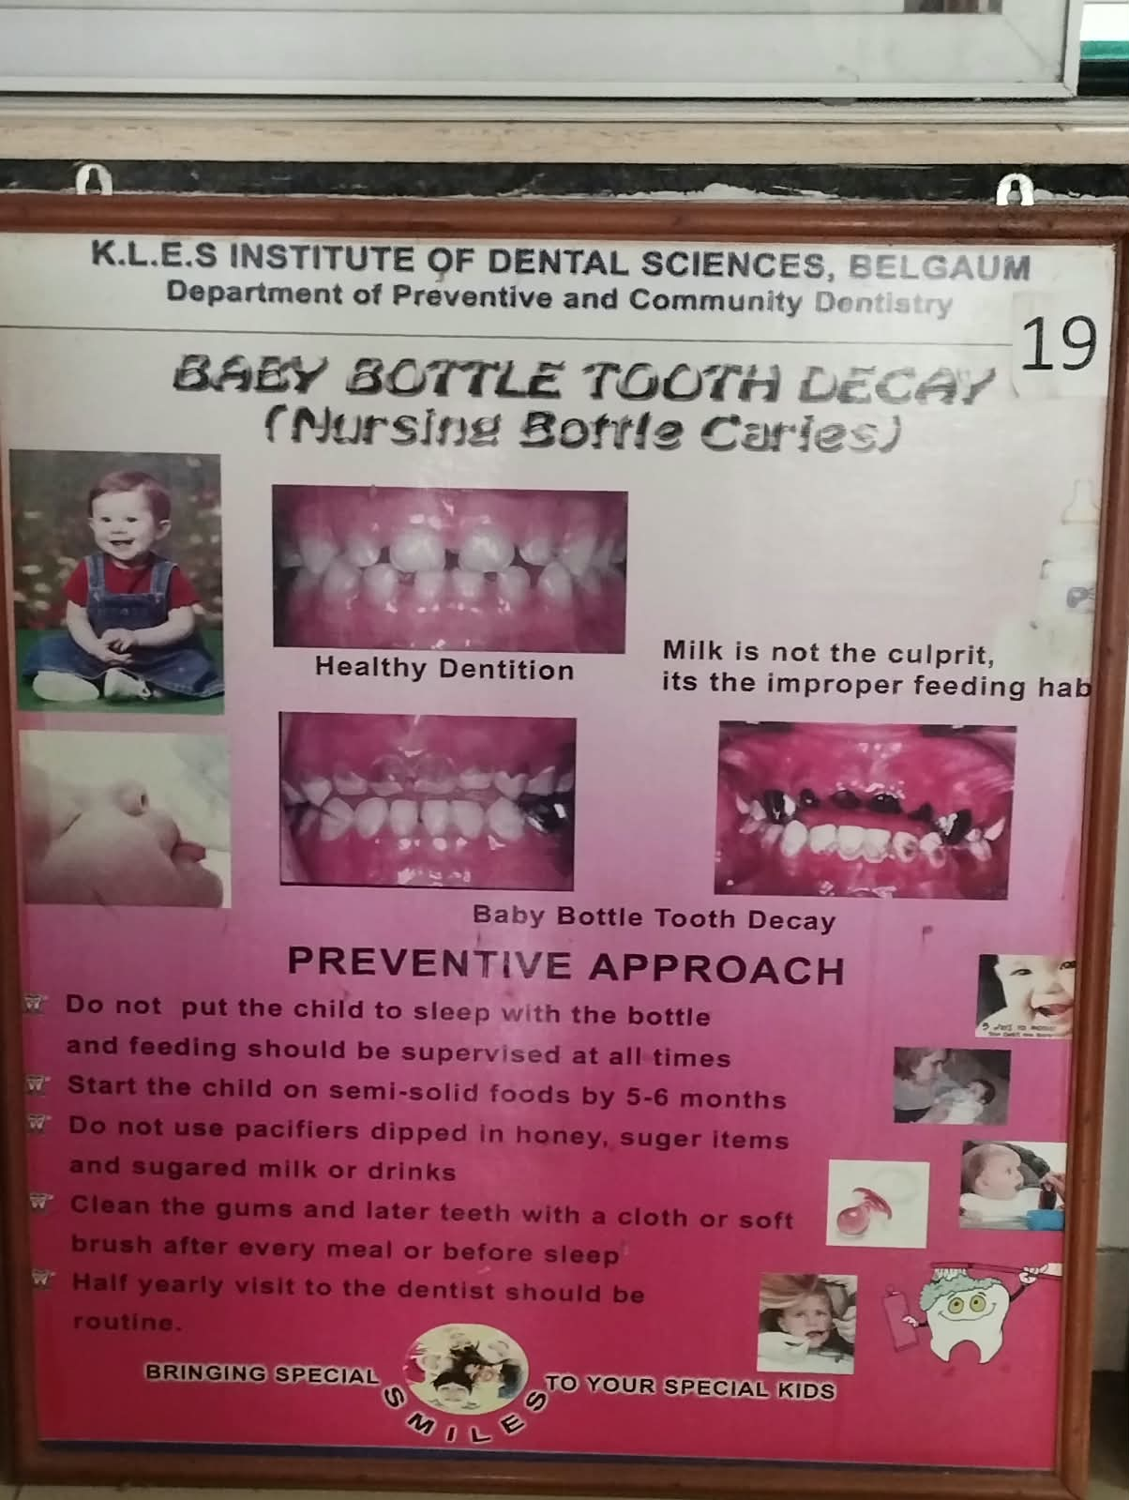 | 1. Explains the development of early childhood caries associated with inappropriate bottle-feeding practices.  2. Emphasizes proper feeding practices and early oral hygiene in children.
20 | Thumb sucking |  | 1. Explains the effects of prolonged thumb sucking on developing teeth and facial structures.  2. Highlights the importance of early identification and management of the habit.
21 | Tetralogy of dental caries |  | 1. Illustrates the four major factors involved in the development of dental caries.  2. Shows how controlling these factors can help prevent dental caries.
22 | Smile is not that aesthetic | 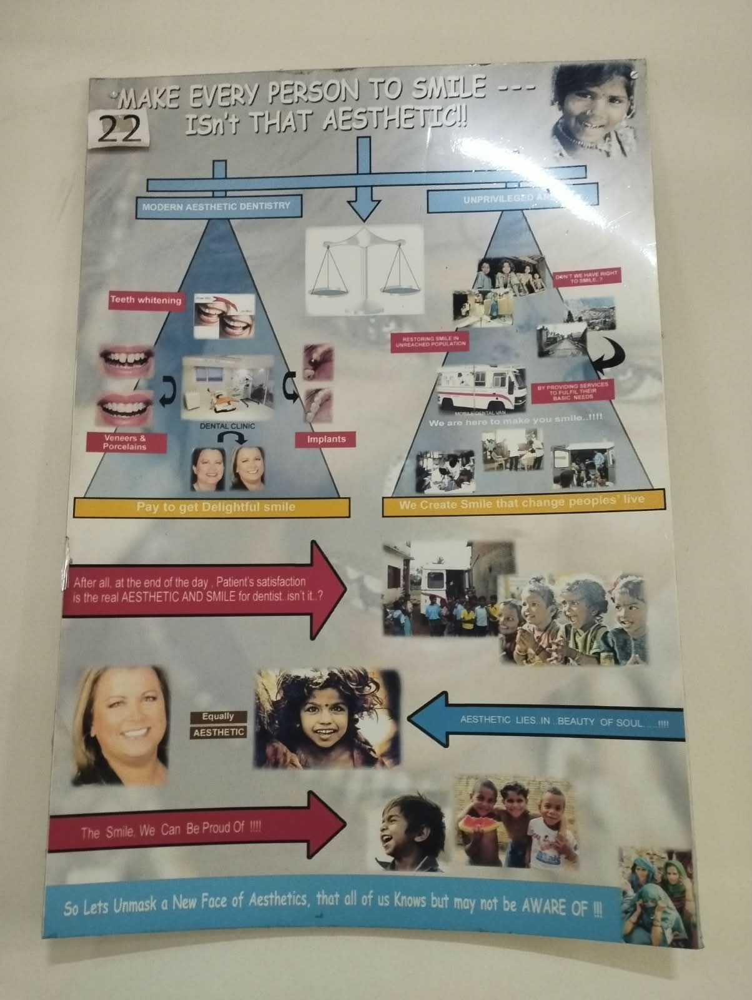 | 1. Highlights how dental and oral problems can affect the appearance of a person's smile.  2. Creates awareness about maintaining oral health for function and aesthetics.
23 | Panoramic radiograph | 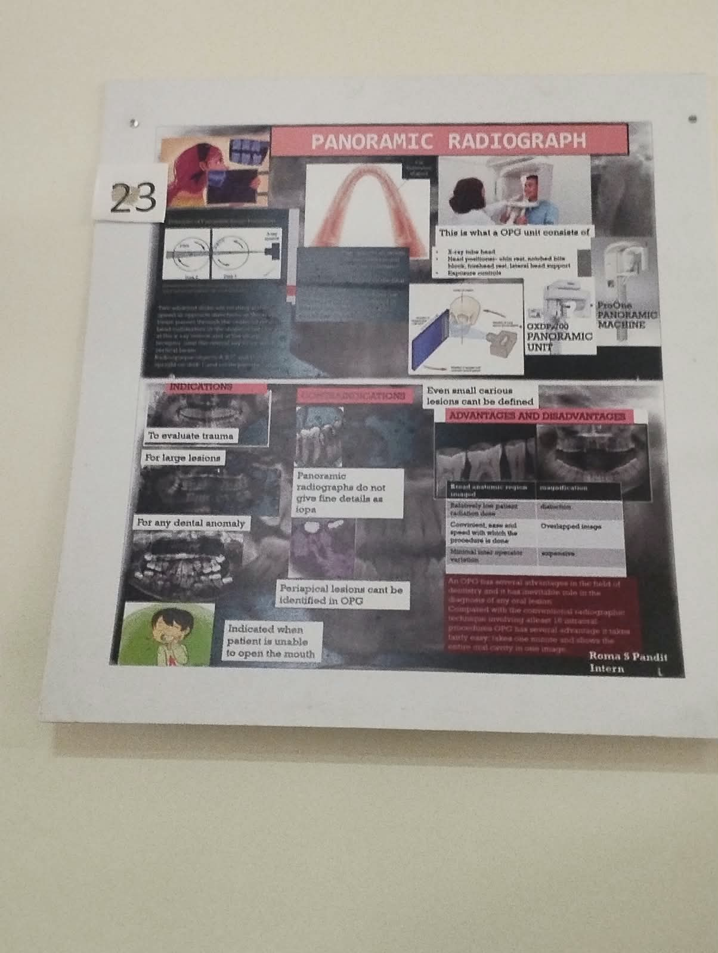 | 1. Introduces the panoramic radiograph as a diagnostic view of the jaws and dentition.  2. Demonstrates its usefulness in obtaining a broad overview of oral structures.
24 | Types of radiographs | 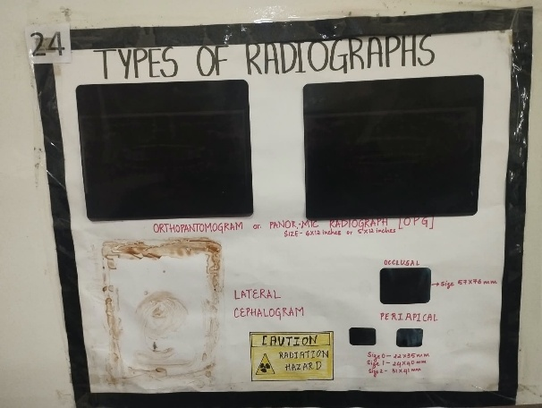 | 1. Presents different types of dental radiographs used for diagnosis.  2. Explains that different radiographic views are selected according to clinical requirements.
25 | Toothbrushing techniques | 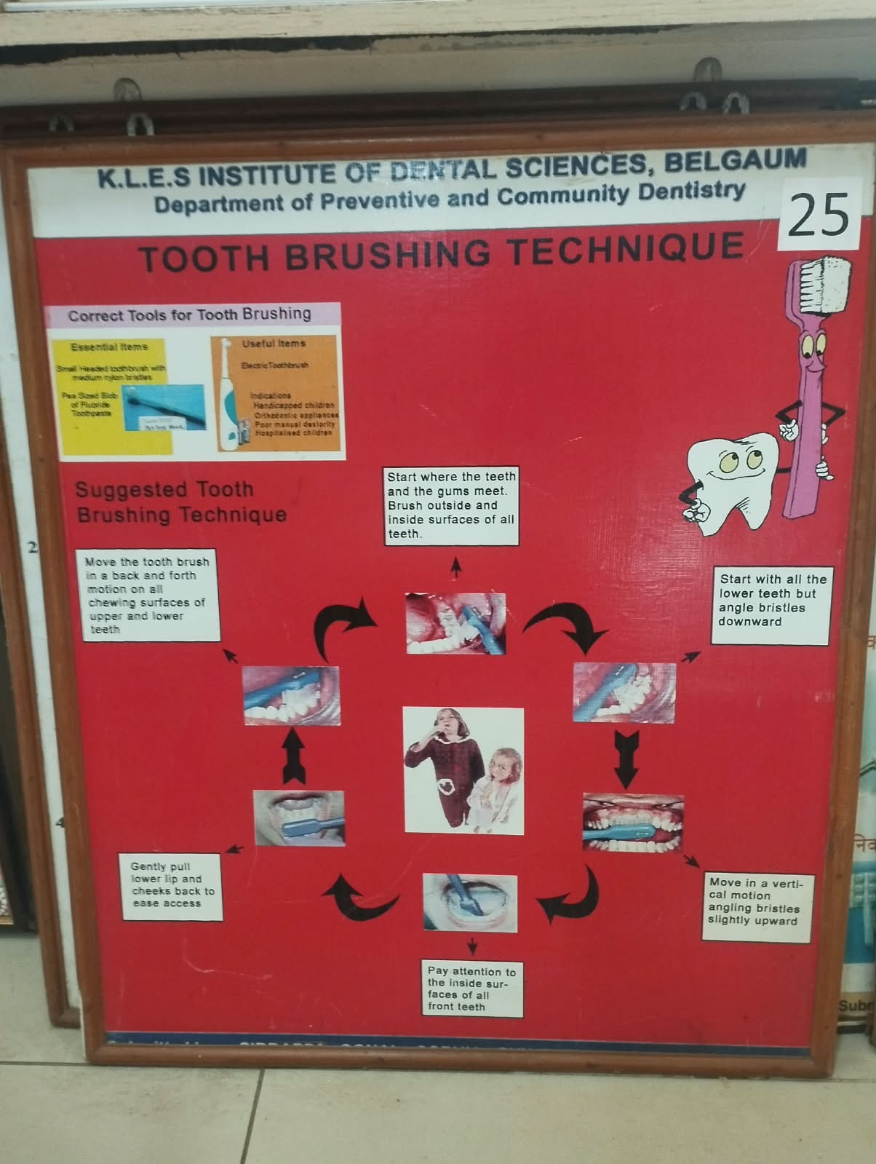 | 1. Demonstrates commonly used techniques for effective toothbrushing.  2. Emphasizes systematic cleaning of all accessible tooth surfaces.
26 | Flossing methods | 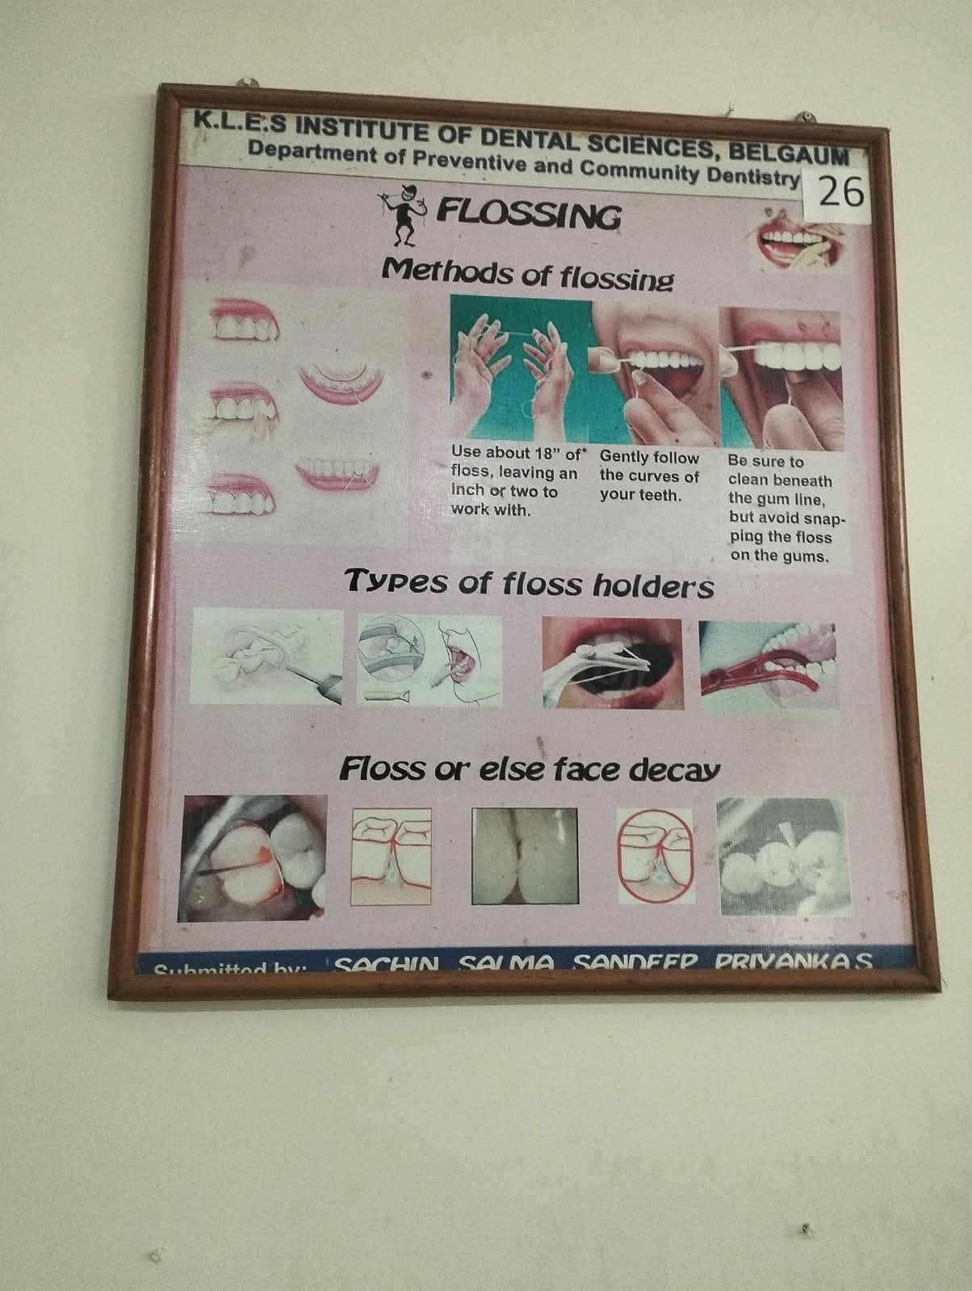 | 1. Demonstrates appropriate methods of using dental floss for interdental cleaning.  2. Highlights the importance of cleaning areas that cannot be adequately reached by a toothbrush.
27 | Fluorides: Friends of healthy teeth | 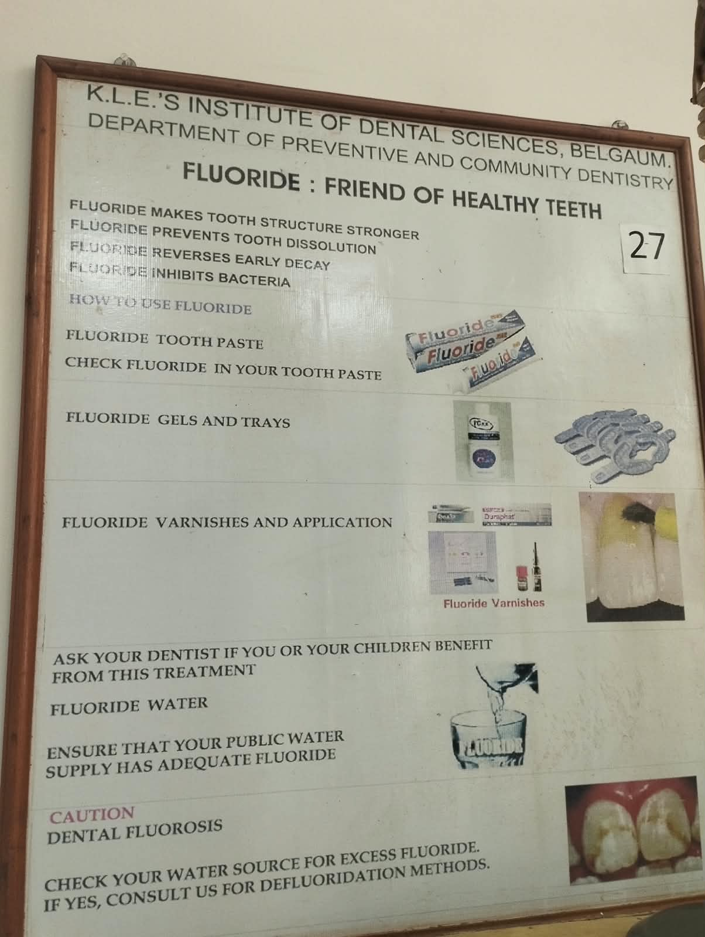 | 1. Explains the preventive role of fluoride in strengthening teeth and reducing dental caries.  2. Promotes appropriate fluoride use as an important component of preventive oral care.
28 | 5 Golden rules of healthy teeth | 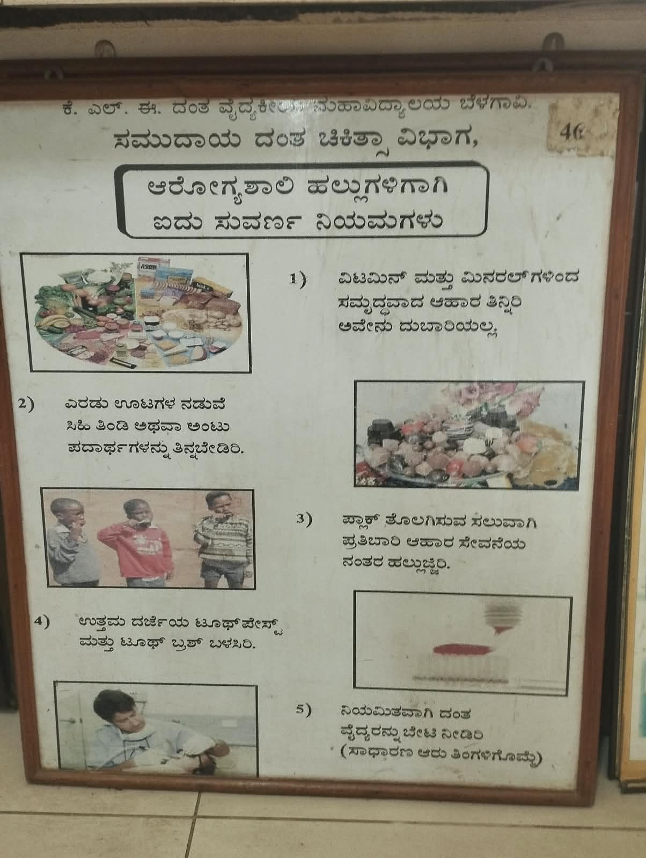  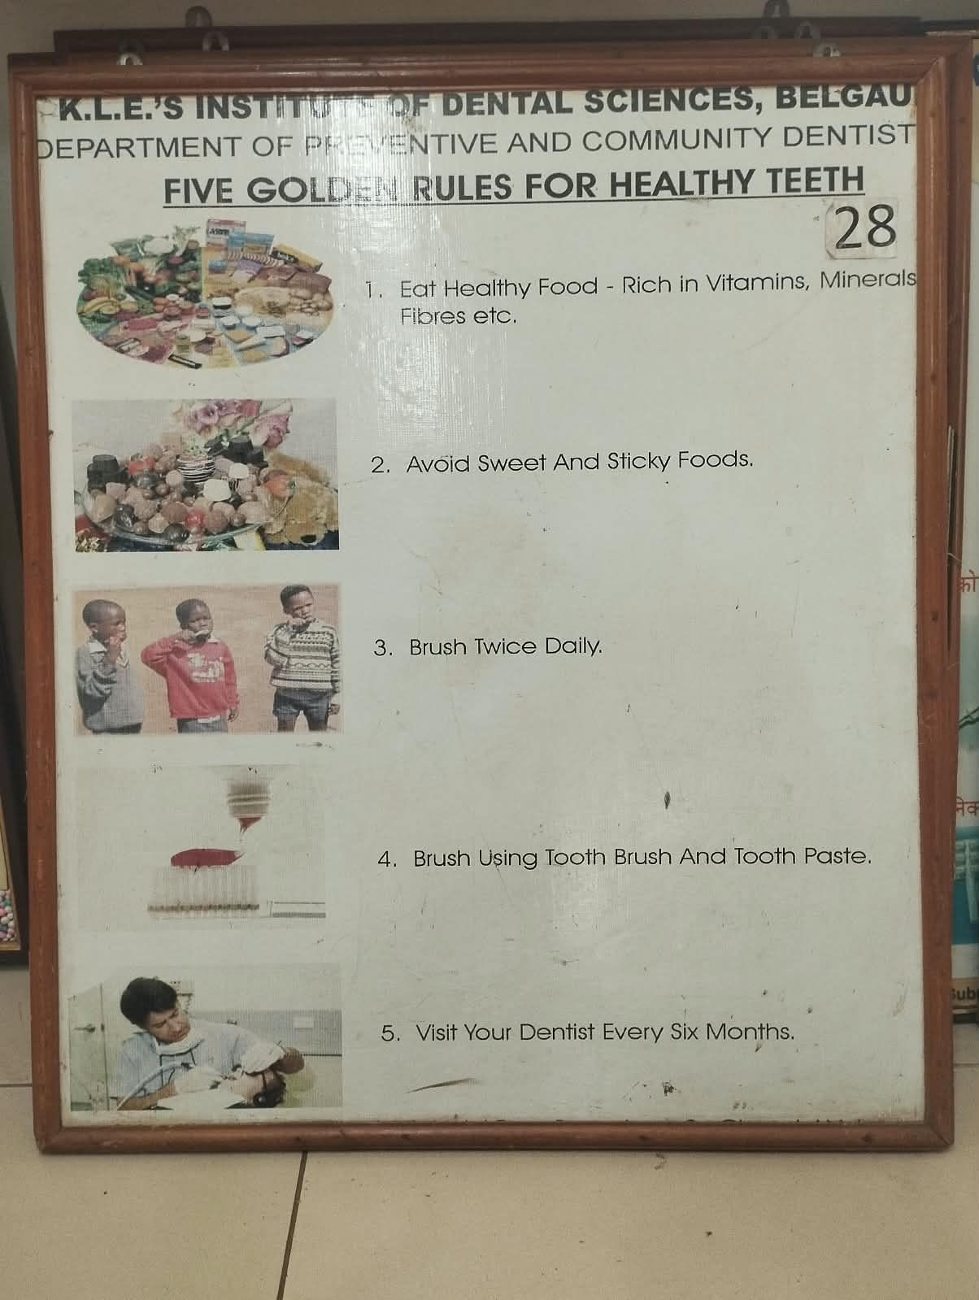 | 1. Presents five practical principles for maintaining healthy teeth and gums.  2. Encourages good oral hygiene, healthy habits and regular dental check-ups.
29 | Complimentary medicine: a safe simple adjunct |  | 1. Introduces complementary medicine as an adjunct to conventional dental care.  2. Emphasizes that complementary approaches should be used safely and appropriately.
30 | Oral parlour | 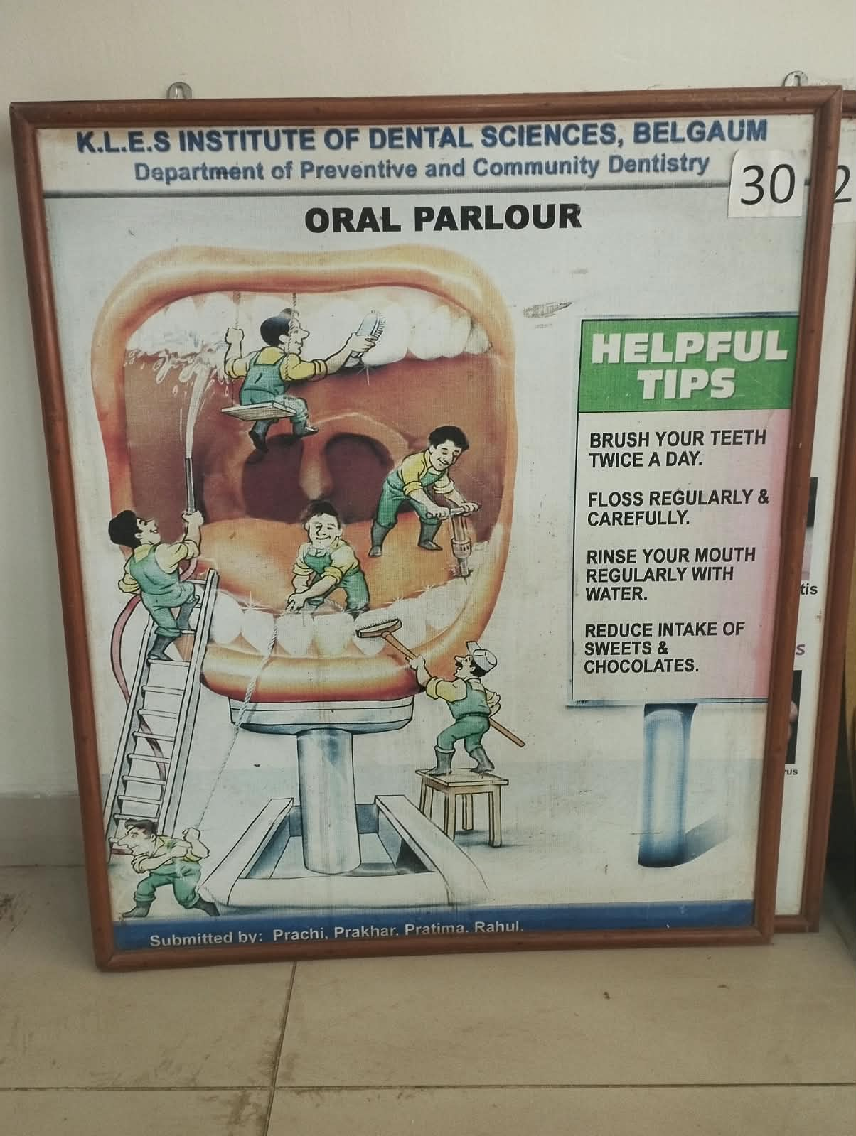 | 1. Highlights oral care and aesthetic procedures associated with an oral parlour.  2. Creates awareness about the importance of professional dental evaluation before procedures.
31 | Make your smile better with implant |  | 1. Explains the use of dental implants for replacement of missing teeth.  2. Highlights restoration of oral function and aesthetics through implant-supported treatment.
32 | Oral manifestation of AIDS | 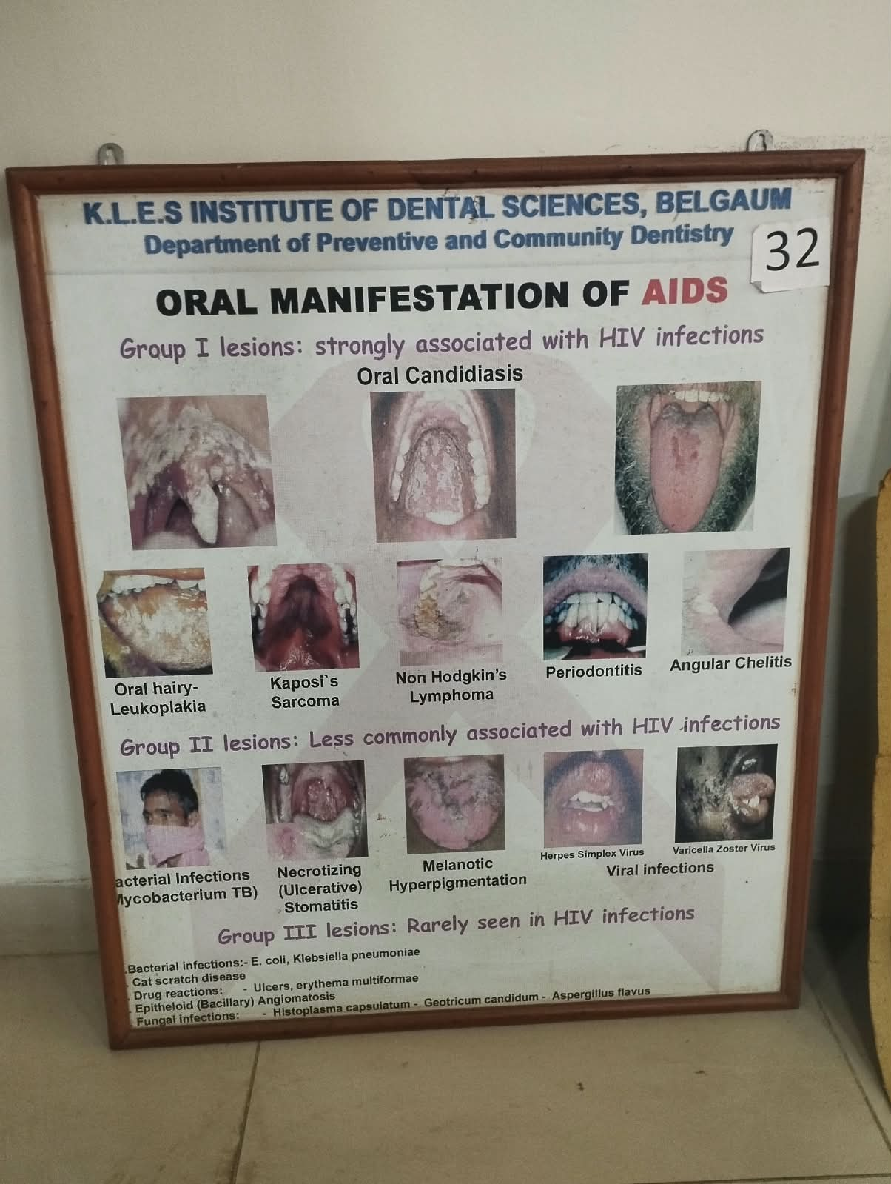 | 1. Presents oral manifestations that may be associated with HIV/AIDS.  2. Emphasizes recognition of oral findings and the importance of appropriate medical care.
Museum MODELS
Model No | Name | Pictures | Description
1 | Cross section of tooth model |  | 1. Shows the internal structures of a tooth in cross-section.  2. Helps understand the arrangement of enamel, dentin, pulp and supporting tissues.
2 | Dental care round the clock |  | 1. Illustrates oral and dental care practices to be followed throughout the day.  2. Promotes regular oral hygiene and preventive dental care.
3 | Sectional view of anatomy of tooth | 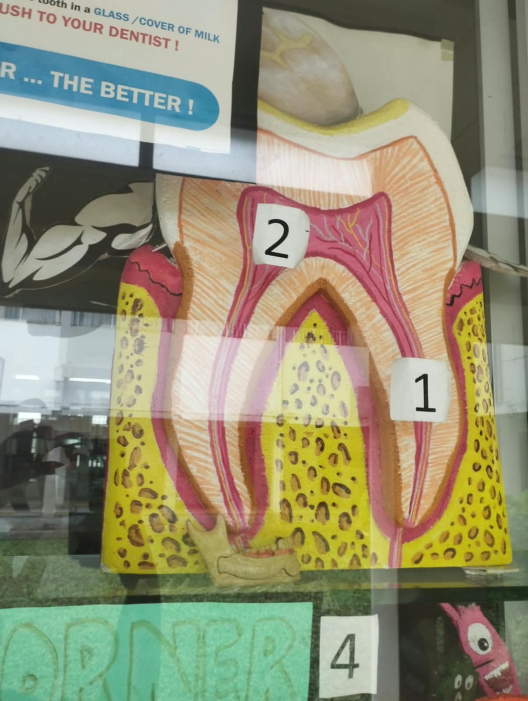 | 1. Demonstrates the major anatomical structures of a tooth in sectional view.  2. Helps learners understand the relationship between tooth structure and function.
4 | Model of tooth prevention by PFS & Fluorides | 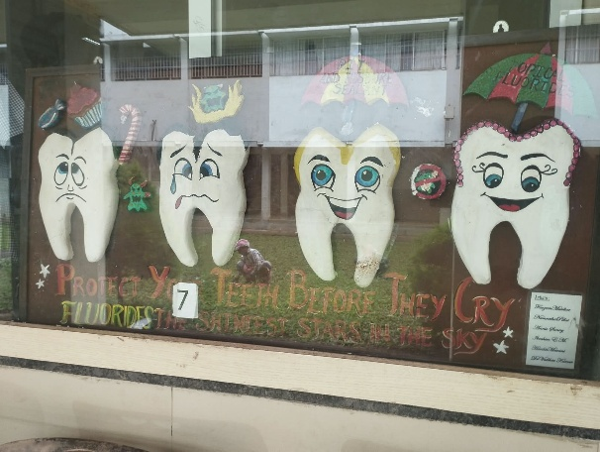 | 1. Demonstrates the preventive role of pit and fissure sealants and fluoride.  2. Shows how these measures help protect teeth from dental caries.
5 | Dental caries & cavity preparation of Class I | 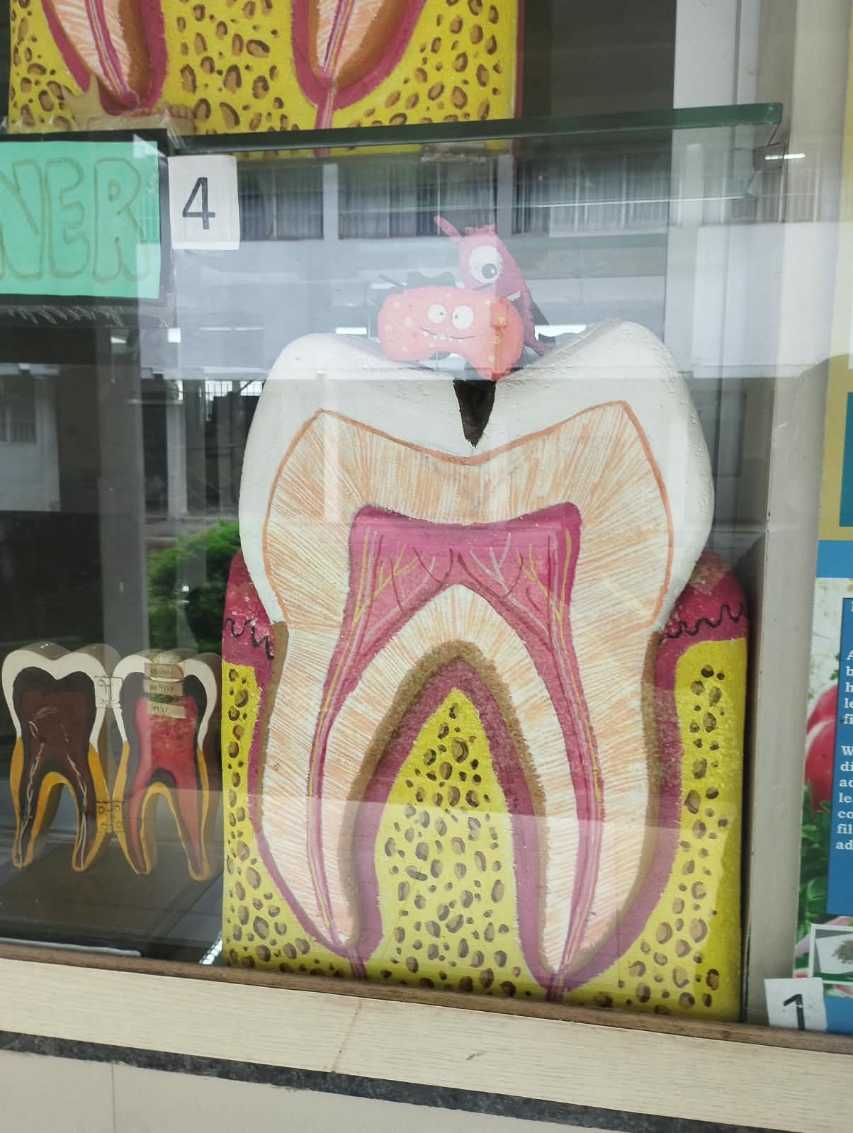 | 1. Illustrates dental caries involving a Class I site and its cavity preparation.  2. Helps demonstrate the principles of conservative treatment of dental caries.
6 | Dental caries & restoration of tooth |  | 1. Shows a carious tooth and its restoration after removal of diseased tissue.  2. Demonstrates restoration of tooth form and function following caries treatment.
7 | Tobacco smoke | 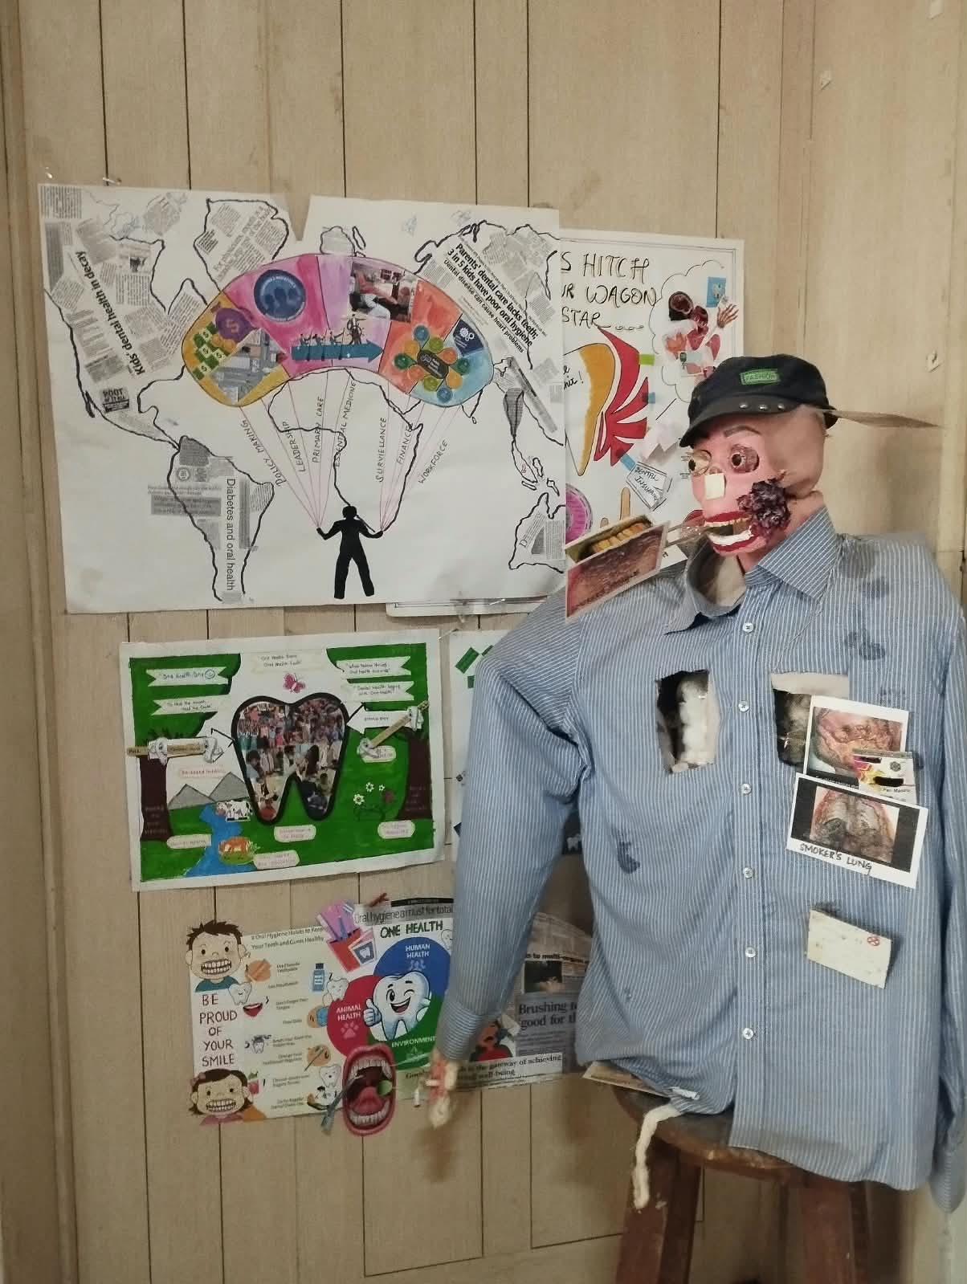 | 1. Illustrates exposure to tobacco smoke and its harmful components.  2. Creates awareness about the health hazards associated with smoking.
8 | Tobacco smokers model | 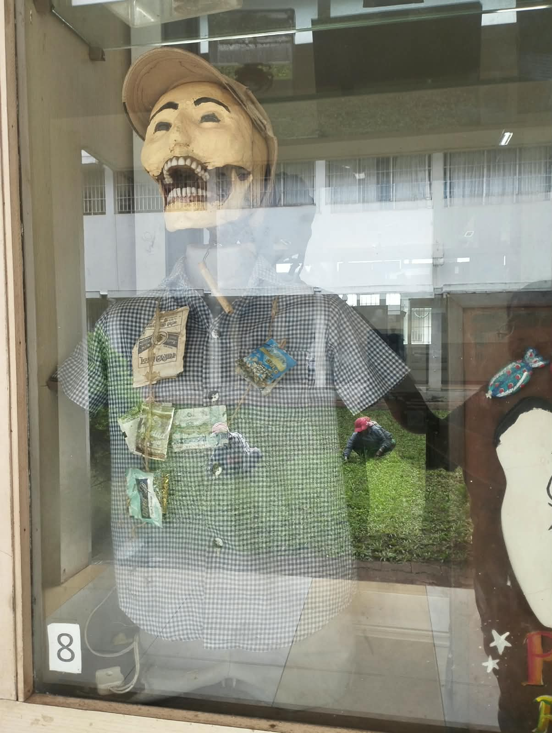 | 1. Demonstrates the harmful effects associated with prolonged tobacco smoking.  2. Promotes awareness regarding tobacco-related health consequences.
9 | Cancer is latin word of crab | 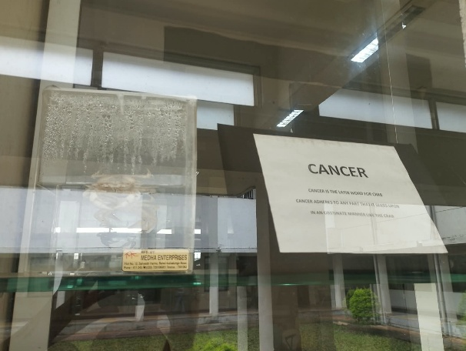 | 1. Explains the historical association of the term cancer with the crab.  2. Provides a simple visual introduction to the concept of cancer and its spread.
10 | Calculus family | 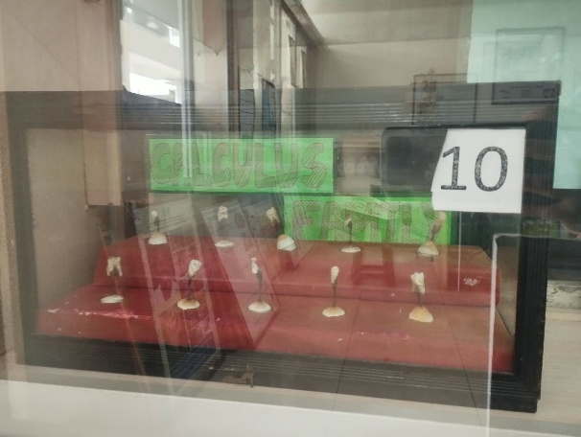 | 1. Demonstrates different forms or presentations of dental calculus.  2. Helps learners understand calculus as a hardened deposit associated with oral disease.
11 | Consequences of not cleaning teeth |  | 1. Illustrates the oral effects of inadequate tooth cleaning.  2. Highlights plaque, calculus and the resulting risk of oral disease.
12 | Anatomy and caries pattern of tooth | 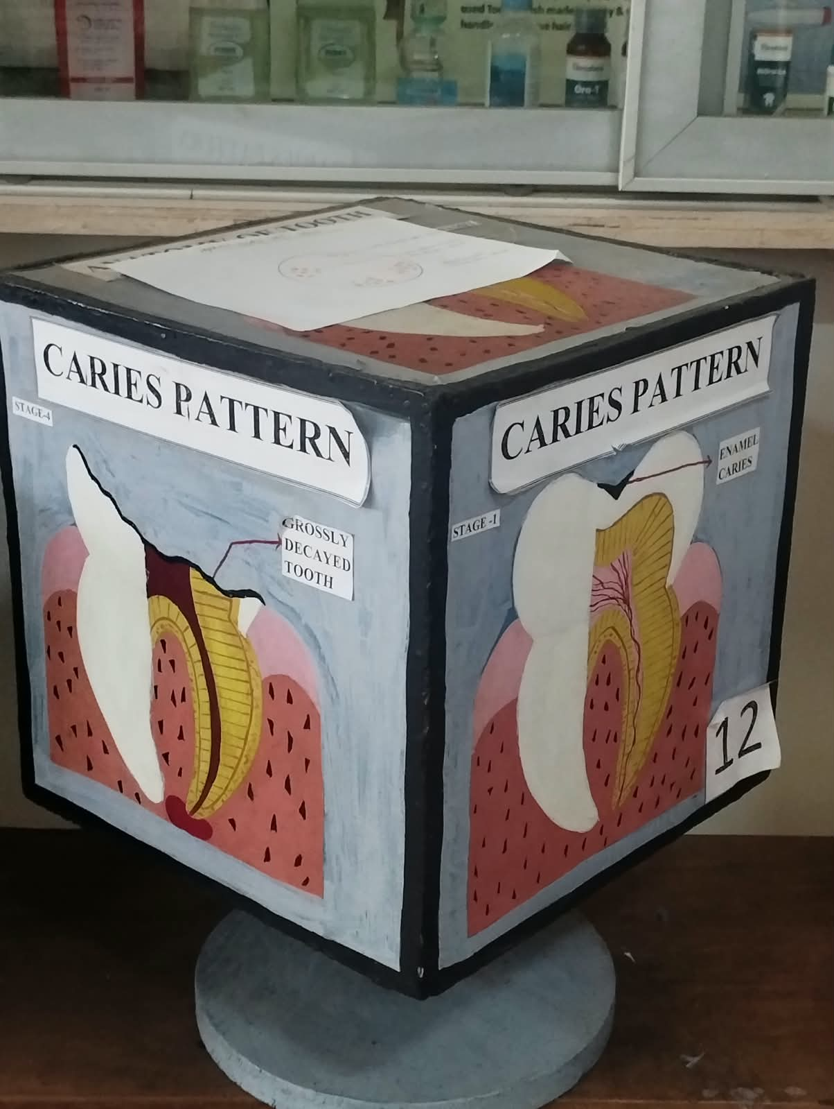 | 1. Shows tooth anatomy together with the pattern of dental caries progression.  2. Helps learners understand how caries can extend through different tooth tissues.
13 | World Tobacco Day (No Tobacco) | 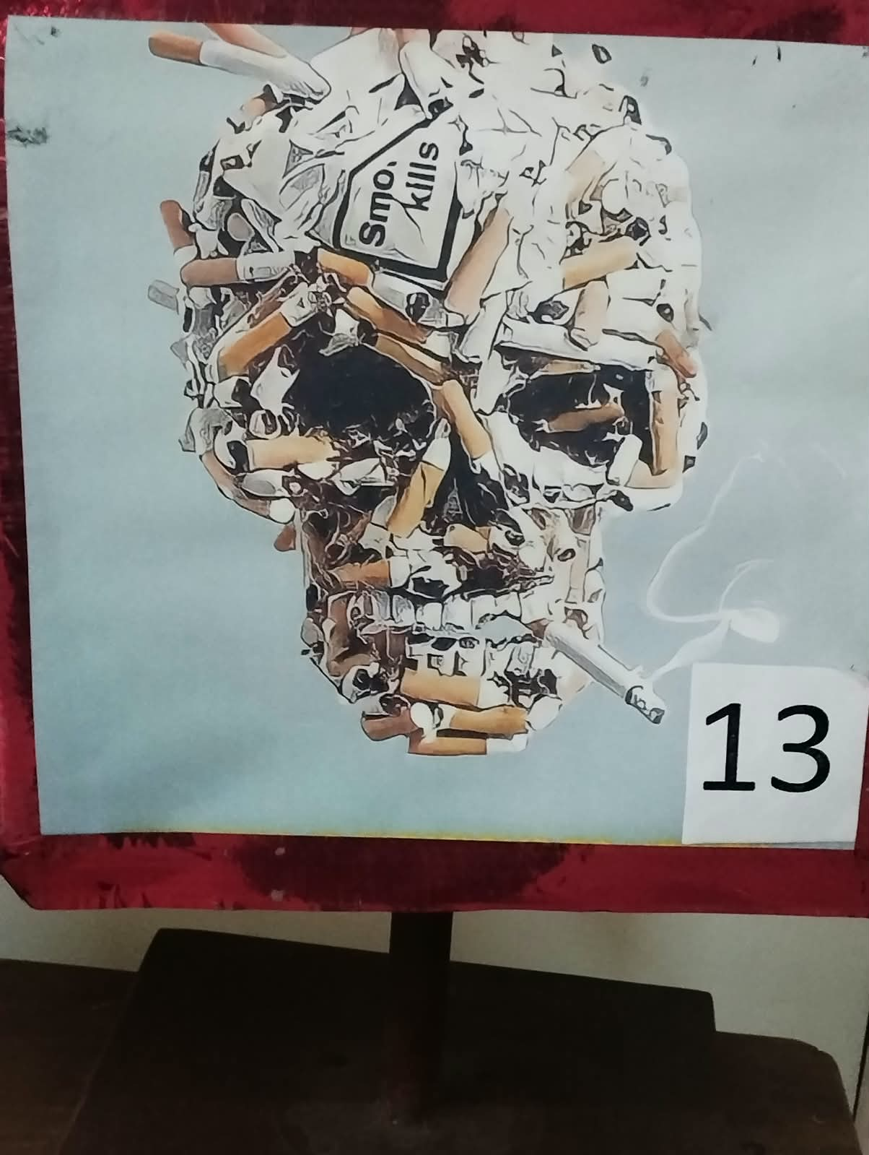 | 1. Promotes the message of avoiding tobacco use through a World No Tobacco Day theme.  2. Creates awareness about the harmful effects of tobacco on health.
14 | Tooth model | 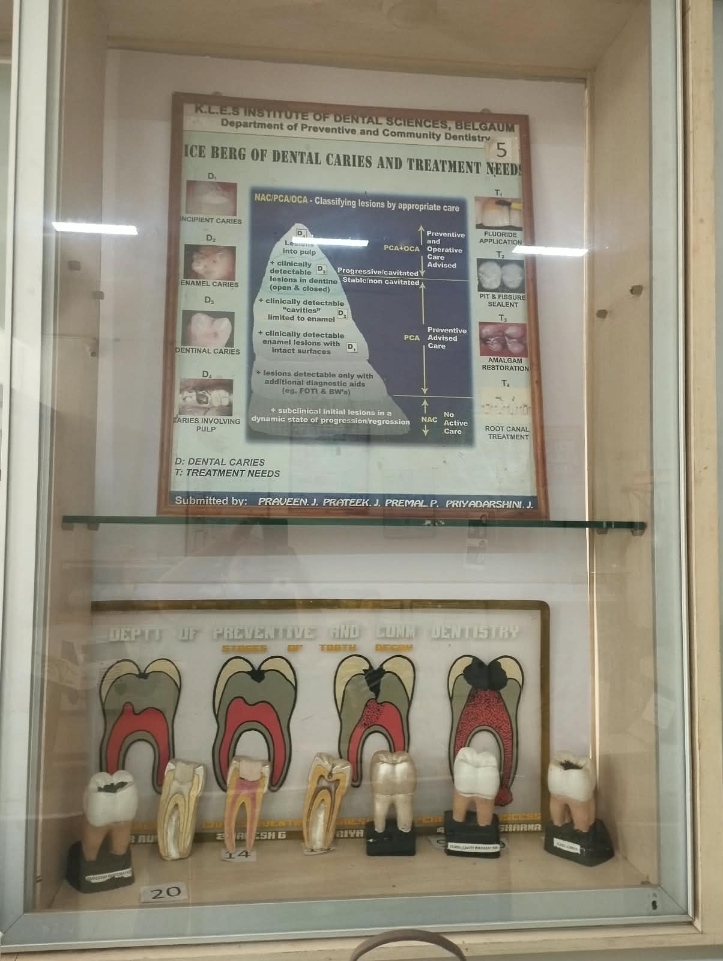 | 1. Provides a three-dimensional representation of a tooth.  2. Helps learners identify basic tooth morphology and anatomical surfaces.
15 | Carious tooth with Class I |  | 1. Demonstrates a tooth affected by a Class I carious lesion.  2. Helps identify the typical location and appearance of pit-and-fissure caries.
16 | Class I cavity preparation |  | 1. Demonstrates the basic design of a Class I cavity preparation.  2. Helps learners understand the relationship between caries removal and cavity preparation.
17 | Amalgam restoration |  | 1. Shows an amalgam restoration placed in a prepared tooth.  2. Demonstrates restoration of the tooth following removal of dental caries.
18 | Access opening |  | 1. Demonstrates the access opening made to reach the pulp chamber.  2. Helps explain an important initial step in root canal treatment.
19 | Sectional view of model with decay extending to pulp | 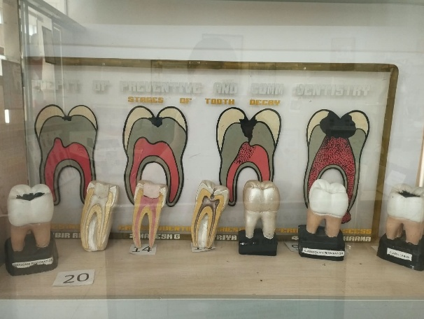 | 1. Shows progression of dental caries from outer tooth tissues towards the pulp.  2. Demonstrates how deep untreated caries can result in pulpal involvement.
20 | Sectional view of model with root canal treatment with core build up |  | 1. Shows a tooth after root canal treatment with core build-up.  2. Demonstrates restoration of the treated tooth to provide structural support.
21 | Erosion (tooth wear) |  | 1. Demonstrates loss of tooth structure due to dental erosion.  2. Helps differentiate erosion from other forms of tooth wear.
22 | Keep your teeth clean | 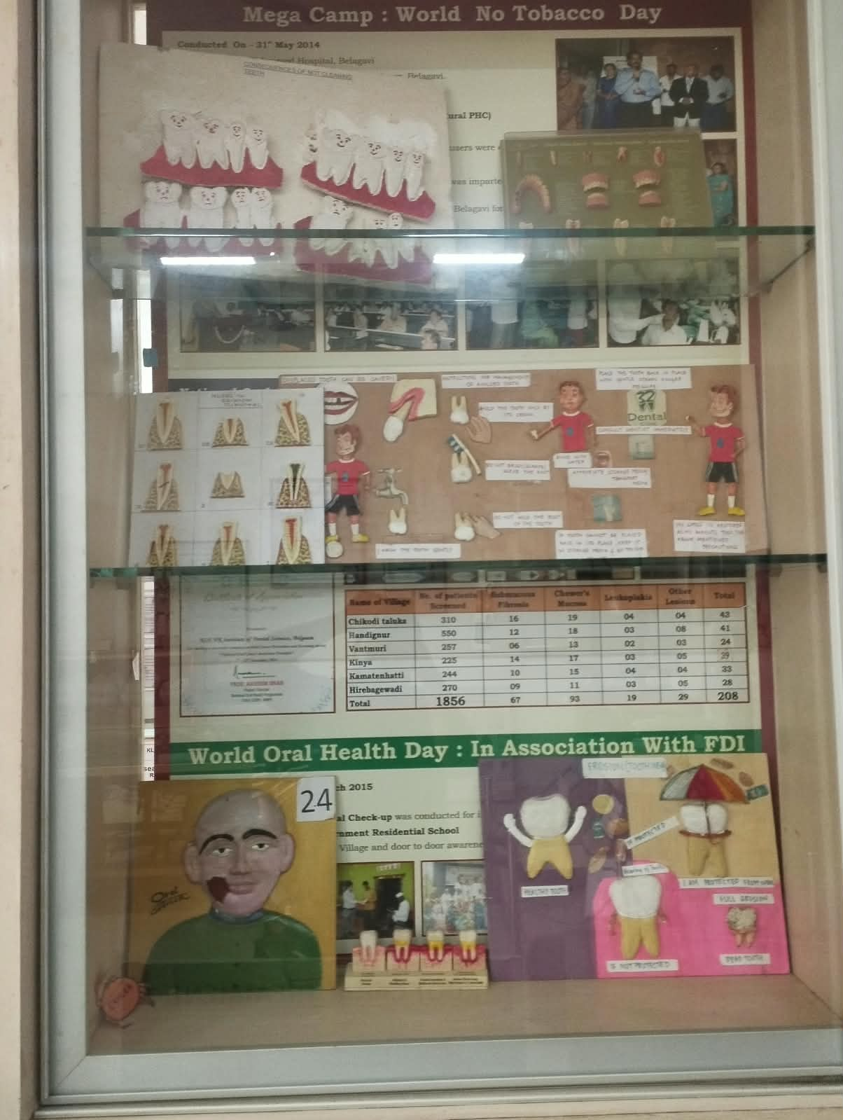 | 1. Promotes regular cleaning of the teeth and oral cavity.  2. Demonstrates the importance of proper oral hygiene in disease prevention.
23 | Traumatic injuries to tooth (Ellis Classification) |  | 1. Demonstrates traumatic dental injuries using Ellis classification.  2. Helps learners understand different patterns of traumatic dental injury.
24 | Oral cancer | 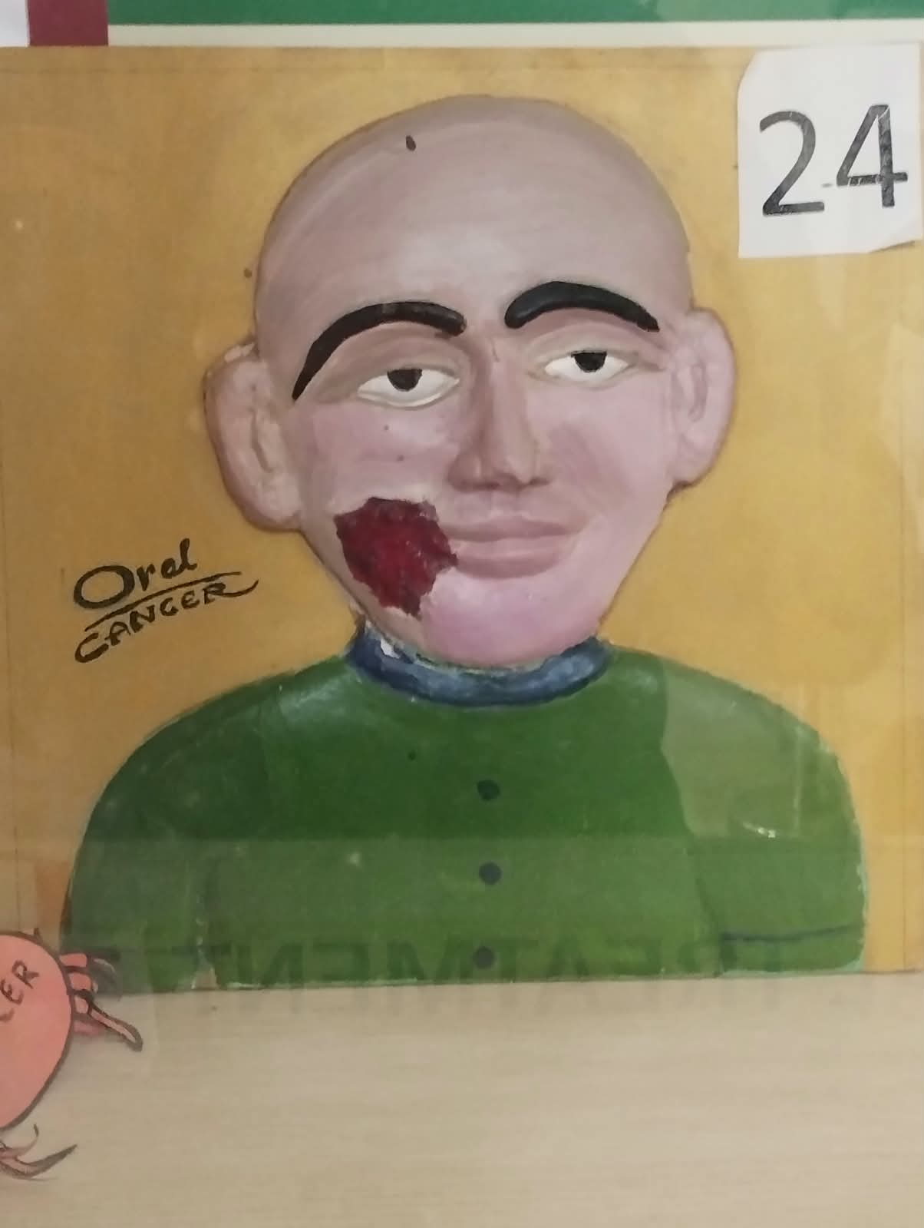 | 1. Provides a visual representation of oral cancer and its clinical importance.  2. Promotes awareness about risk factors, early recognition and timely treatment.
25 | Classification of impacted third molar | 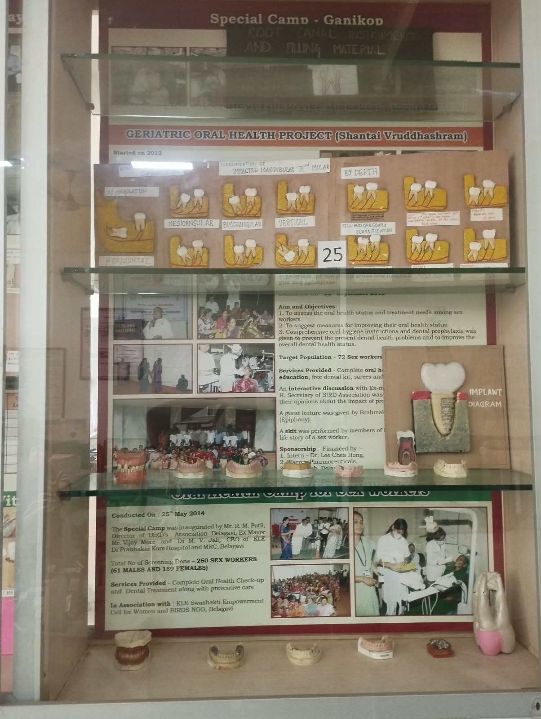 | 1. Demonstrates the classification of impacted third molars according to their position.  2. Helps learners understand the assessment of impacted wisdom teeth.
26 | Instruction for management of avulsed tooth |  | 1. Demonstrates immediate management principles for an avulsed tooth.  2. Emphasizes appropriate handling and the need for urgent dental care.
27 | Implant model of tooth |  | 1. Demonstrates the basic structure and placement of a dental implant.  2. Helps explain how implants are used to replace missing teeth.
28 | Root canal instrument & filling materials |  | 1. Displays instruments used during different stages of root canal treatment.  2. Demonstrates materials used for filling and sealing the prepared root canal.
29 | Risks from smoking |  | 1. Illustrates the major health risks associated with smoking.  2. Reinforces the importance of tobacco prevention and cessation.
30 | Epidemiology of oral cancer |  | 1. Presents the epidemiological importance and distribution of oral cancer.  2. Highlights major risk factors and the importance of early detection.
31 | Development of cancer |  | 1. Demonstrates the development and progression of cancer in a simplified form.  2. Helps explain how abnormal cells can grow and progress over time.
32 | Tobacco thrills but kills | 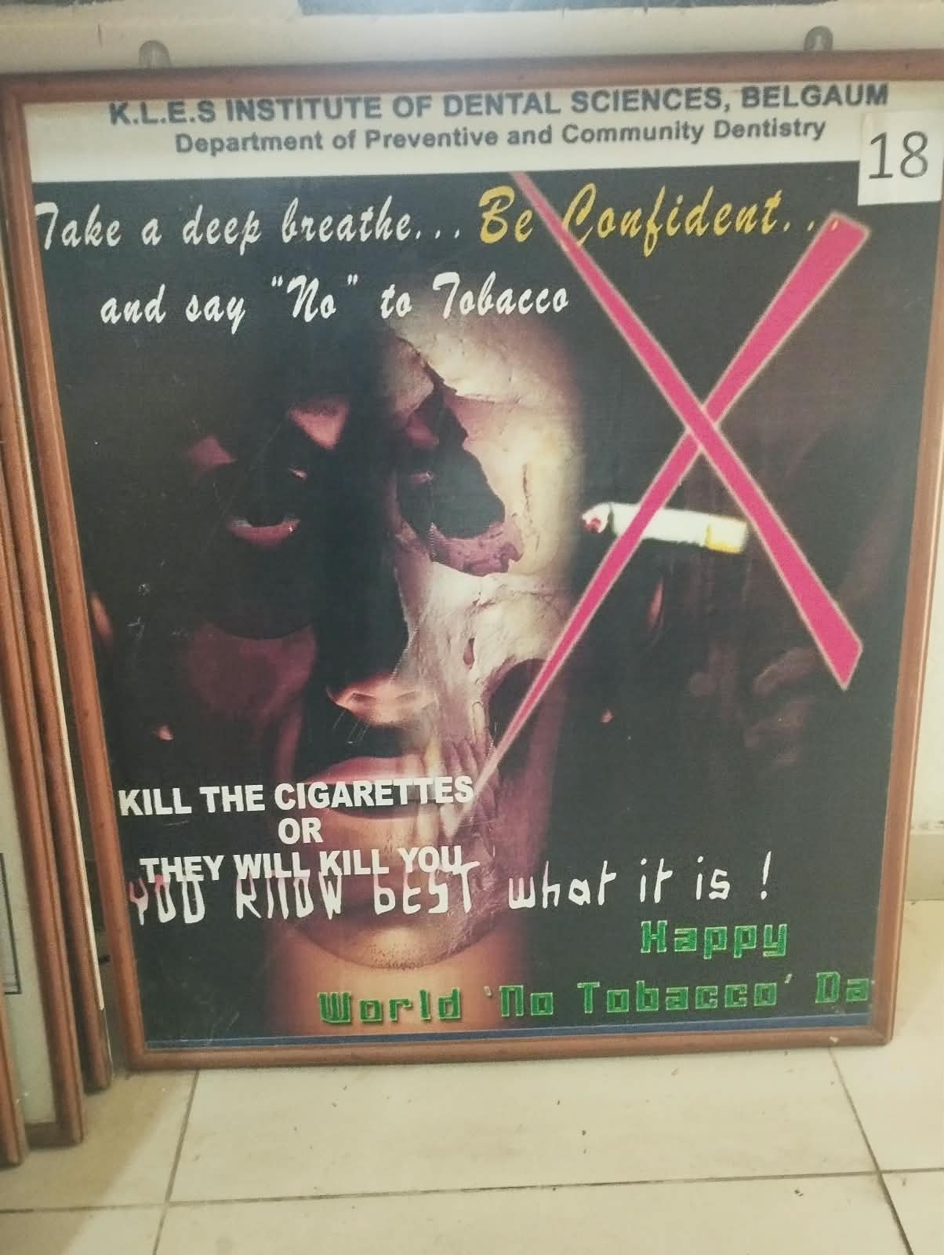 | 1. Uses a visual message to demonstrate the harmful consequences of tobacco use.  2. Encourages tobacco avoidance and cessation.
33 | Deciduous teeth models | 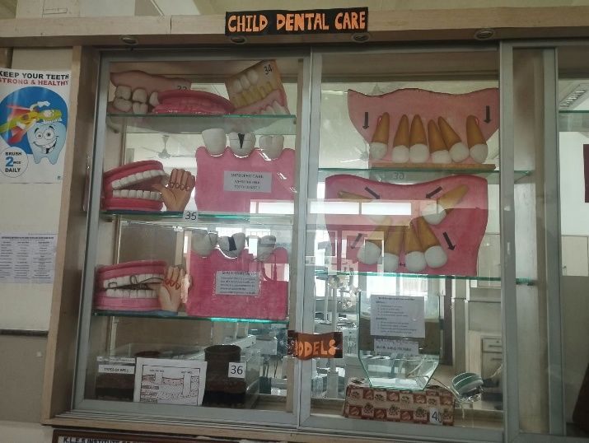 | 1. Demonstrates the arrangement and morphology of deciduous or primary teeth.  2. Helps learners understand the importance of primary dentition during childhood.
34 | Eruption of tooth | 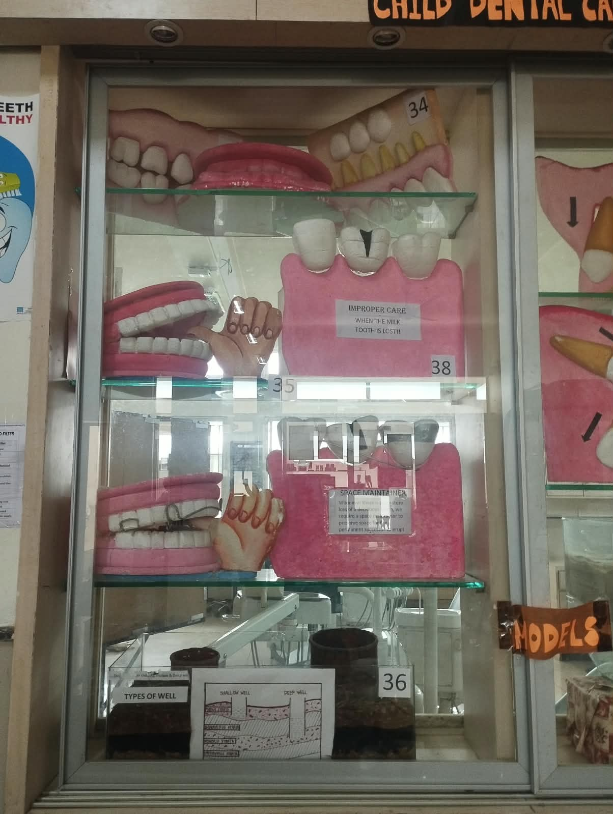 | 1. Demonstrates the sequence and pattern of tooth eruption.  2. Helps learners understand the developmental stages of dentition.
35 | Ugly duckling stage- before & after | 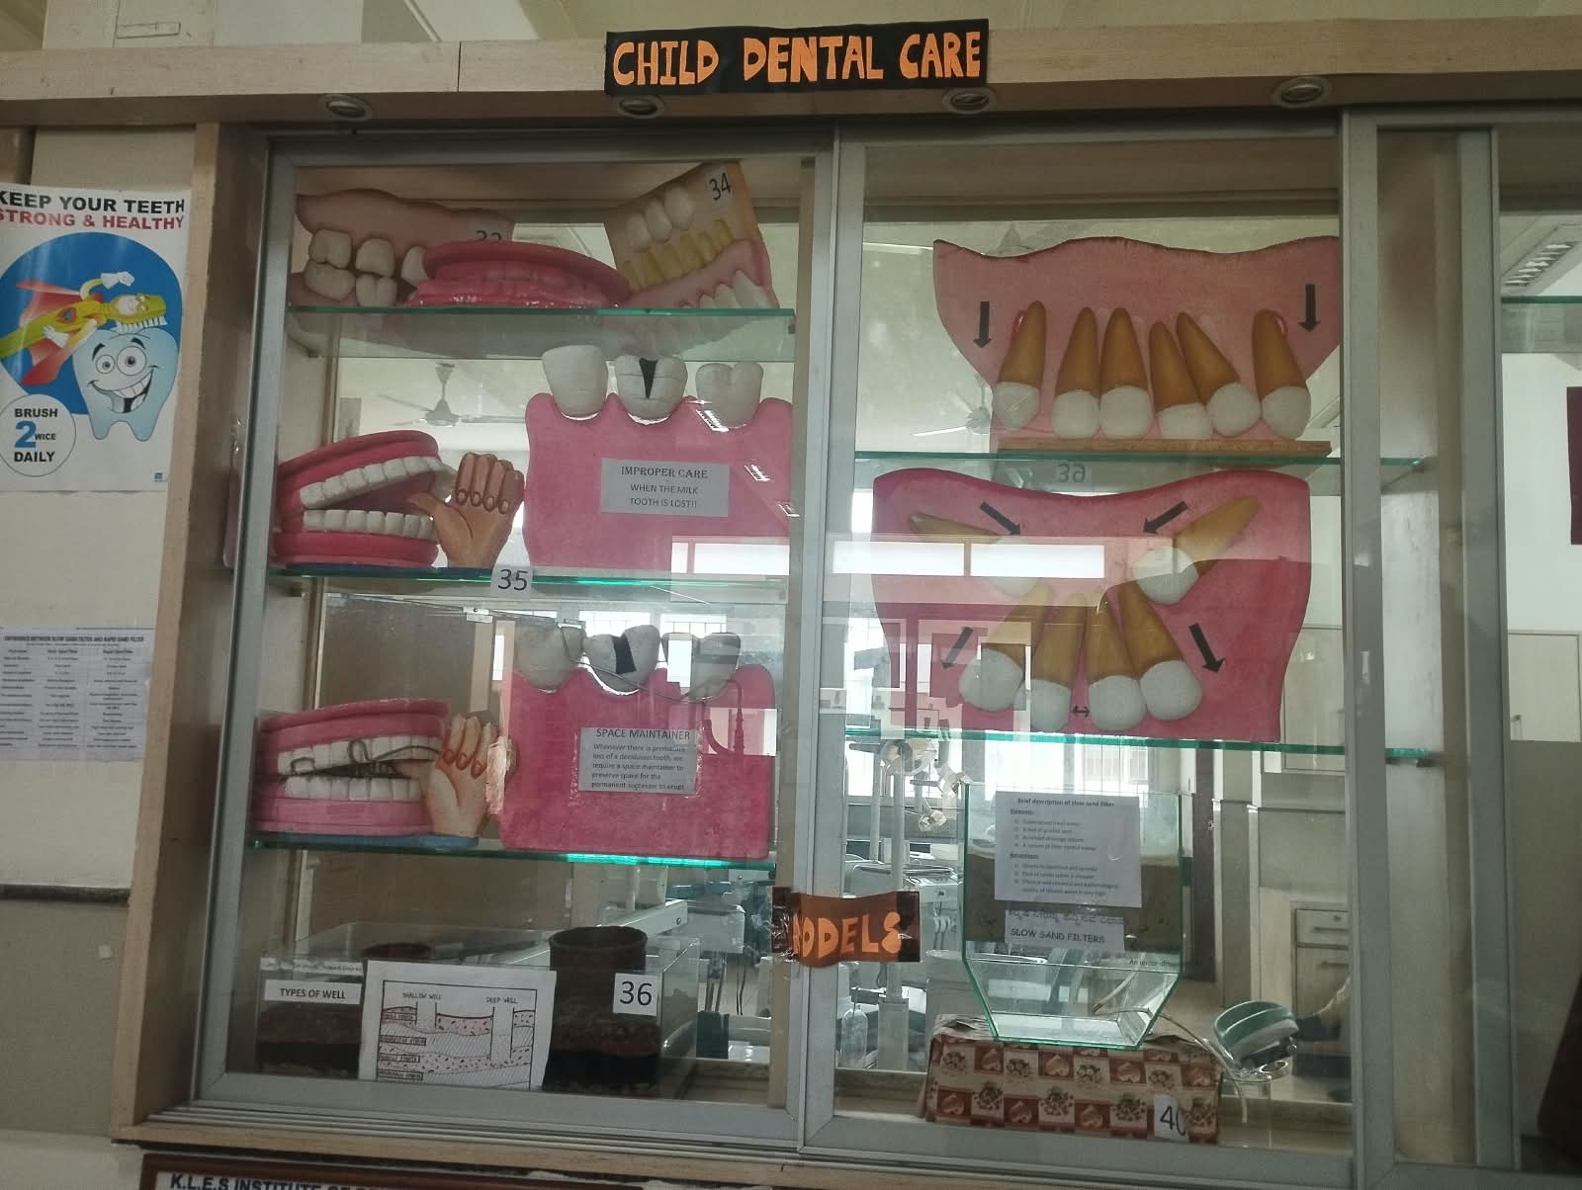 | 1. Demonstrates the temporary spacing associated with the ugly duckling stage.  2. Shows the changes that may occur naturally with continued dental development.
36 | Types of wells |  | 1. Demonstrates different types of wells used as water sources.  2. Creates awareness about water sources and their importance to community health.
37 | Space maintainers |  | 1. Demonstrates the use and function of space maintainers in developing dentition.  2. Shows how they help preserve space following premature loss of a primary tooth.
38 | Improper care | 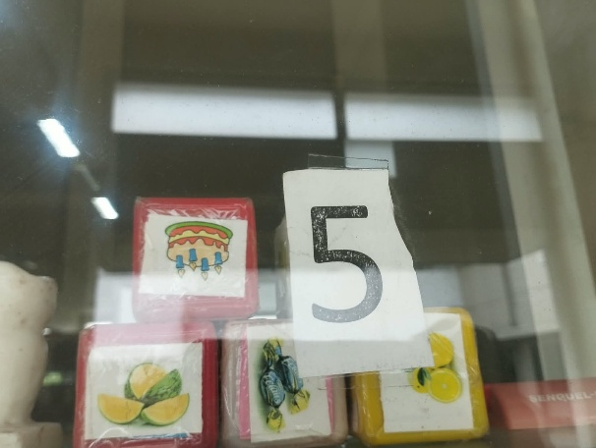 | 1. Illustrates the effects of inadequate oral care and poor hygiene.  2. Highlights the resulting risk of plaque, calculus, caries and periodontal problems.
39 | Thumb sucking & habit breaking appliance |  | 1. Demonstrates thumb sucking and its possible effects on developing dentition.  2. Shows the use of a habit-breaking appliance for management of the habit.
40 | Slow sand filters | 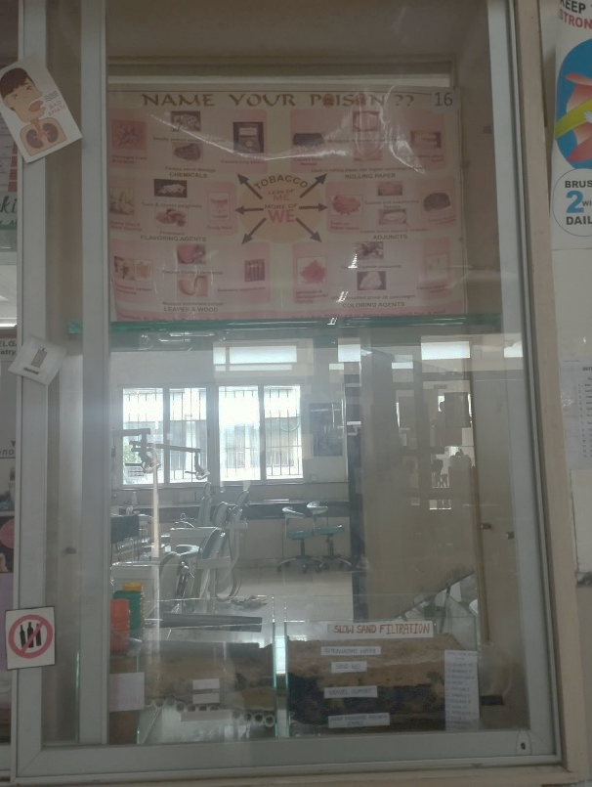 | 1. Demonstrates the basic structure and working principle of a slow sand filter.  2. Shows how filtration can be used as a simple method of improving water quality.
41 | Food pyramid | 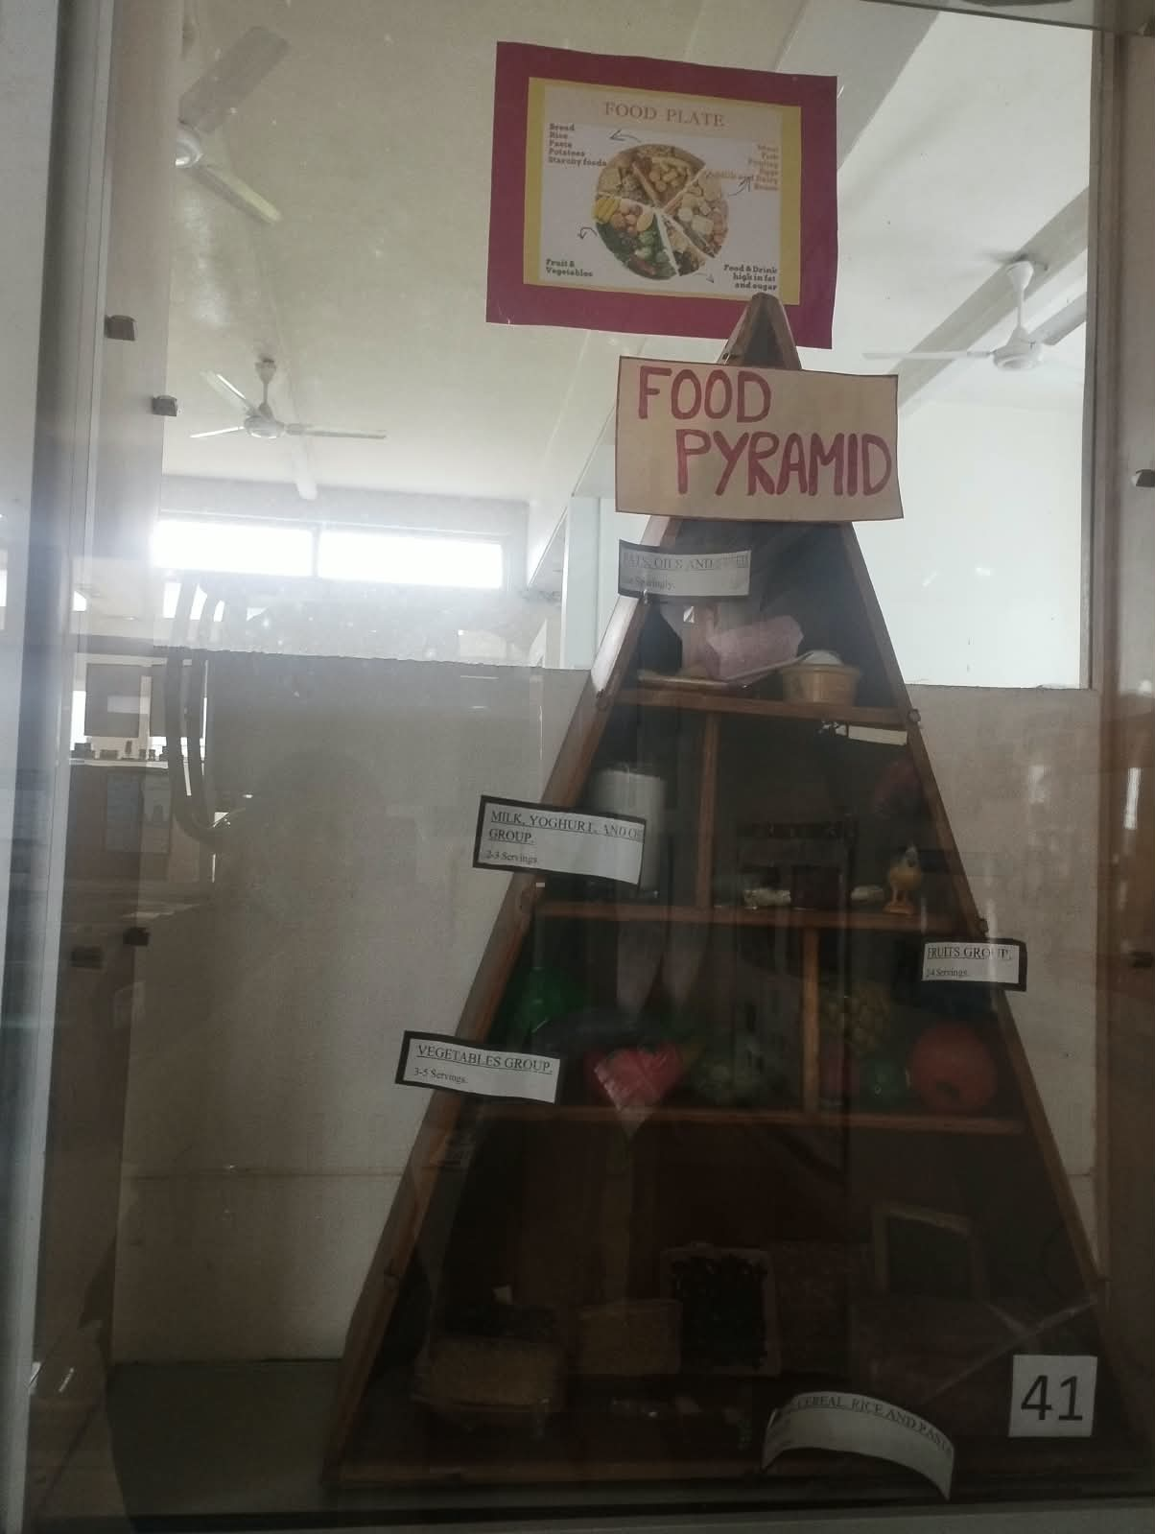 | 1. Presents the major food groups and principles of a balanced diet.  2. Promotes healthy food choices important for general and oral health.
42 | Ground level | 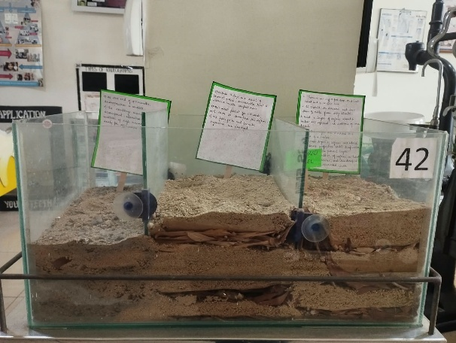 | 1. Demonstrates a ground-level arrangement related to environmental or community health.  2. Helps learners understand the relationship between surroundings and hygiene.
43 | Rain water consumption | 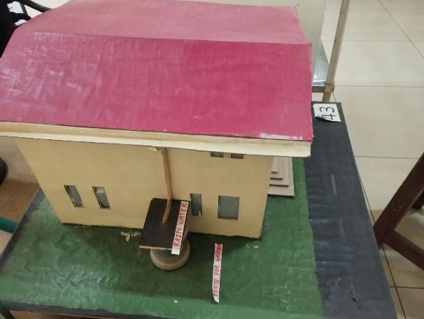 | 1. Demonstrates the collection and use of rainwater as a water resource.  2. Promotes awareness about rainwater harvesting and safe water practices.
44 | Typical village model | 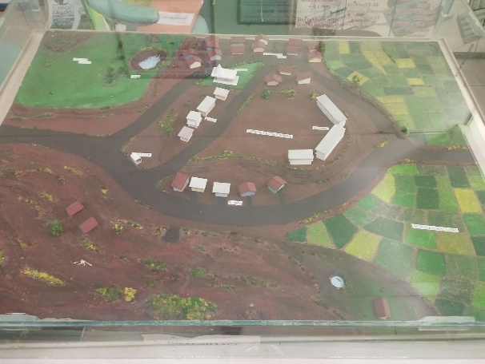 | 1. Represents a typical village environment for community health education.  2. Illustrates the relationship between housing, sanitation, water supply and health.
45 | Mobile dental clinic | 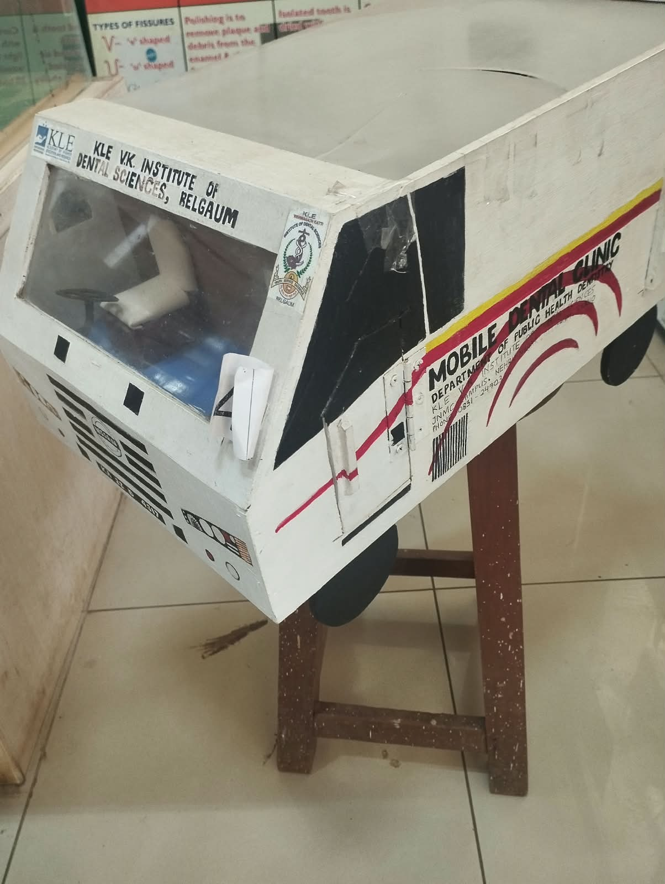 | 1. Demonstrates a mobile dental clinic designed to provide dental services in communities.  2. Highlights the role of outreach services in improving access to oral healthcare.
46 | Eating tobacco – way to death | 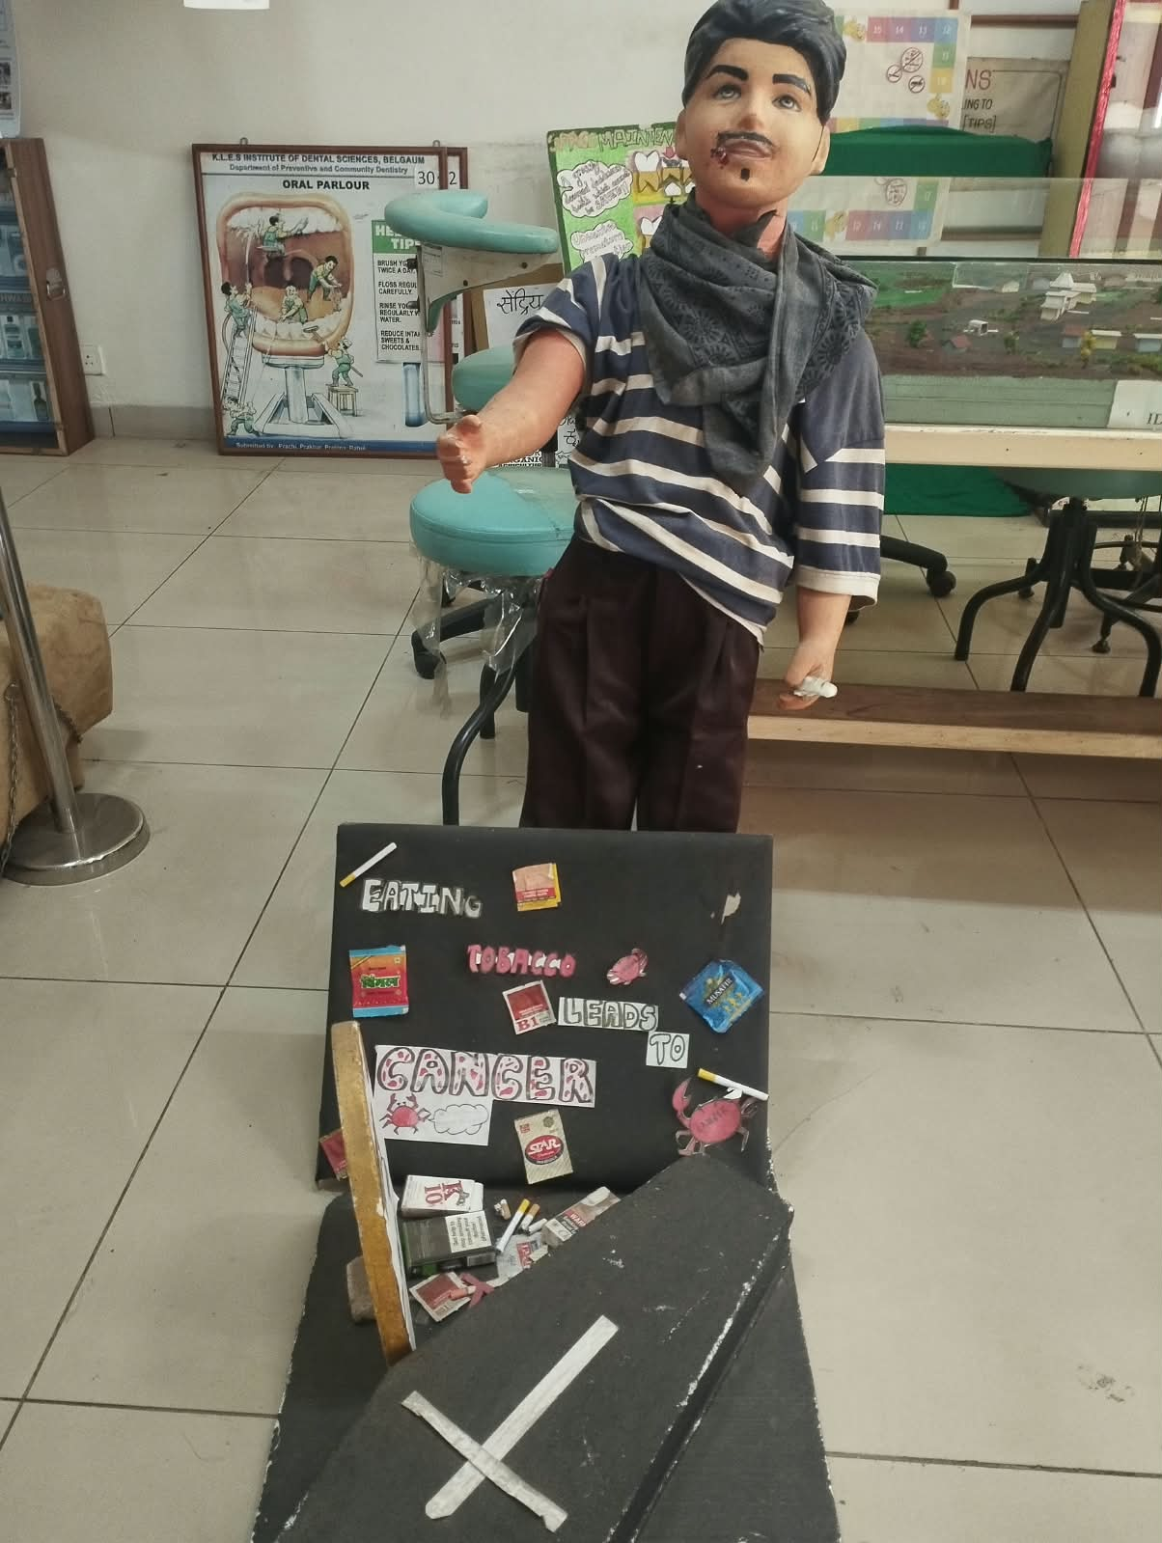 | 1. Demonstrates the harmful consequences associated with eating tobacco.  2. Creates awareness about the serious health risks of smokeless tobacco use.
47 | Pit & Fissure – types & steps | 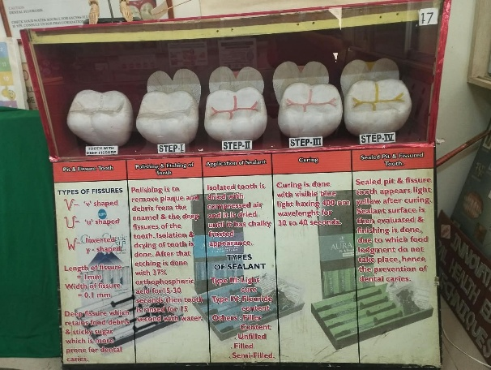 | 1. Demonstrates different types of pits and fissures and the steps involved in sealing them.  2. Explains how pit and fissure sealants help protect caries-prone tooth surfaces.
48 | Can you guess me right? |  | 1. Uses an interactive identification approach to encourage recognition of dental structures or conditions.  2. Promotes observation, recall and practical learning among students.
49 | Implants – fixed denture |  | 1. Demonstrates the use of implants to support a fixed replacement for missing teeth.  2. Helps explain the basic relationship between the implant and the replacement tooth.
50 | Oral hygiene aids | 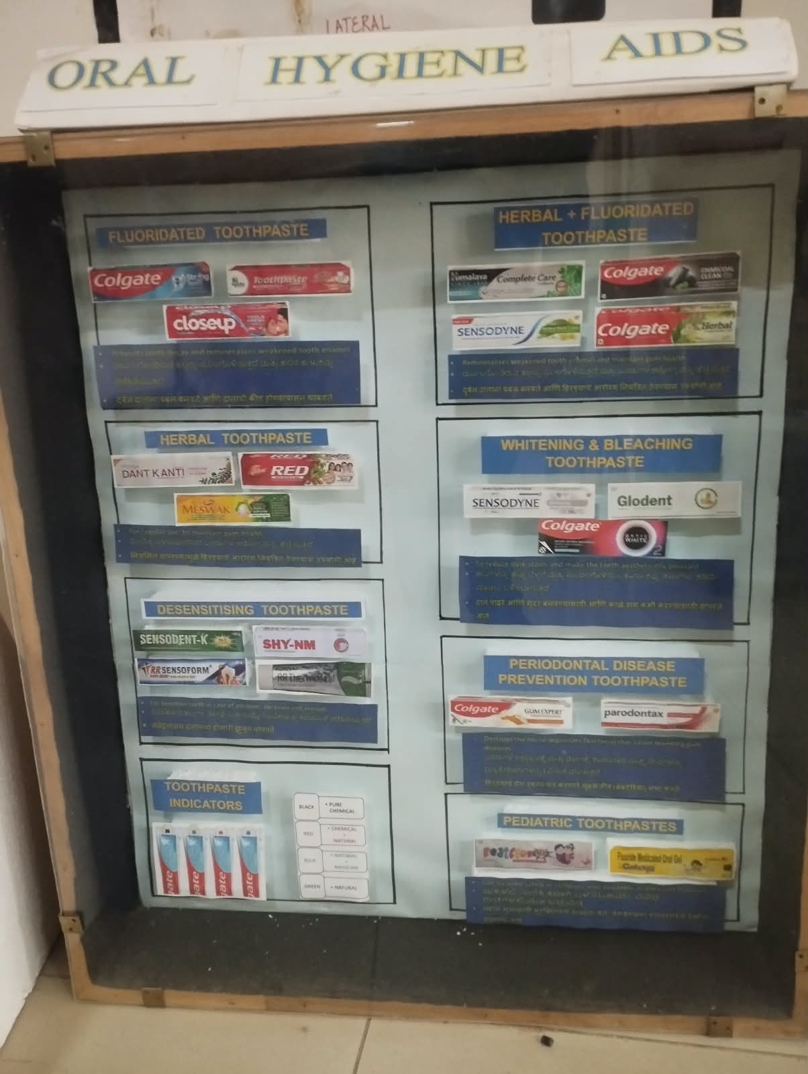  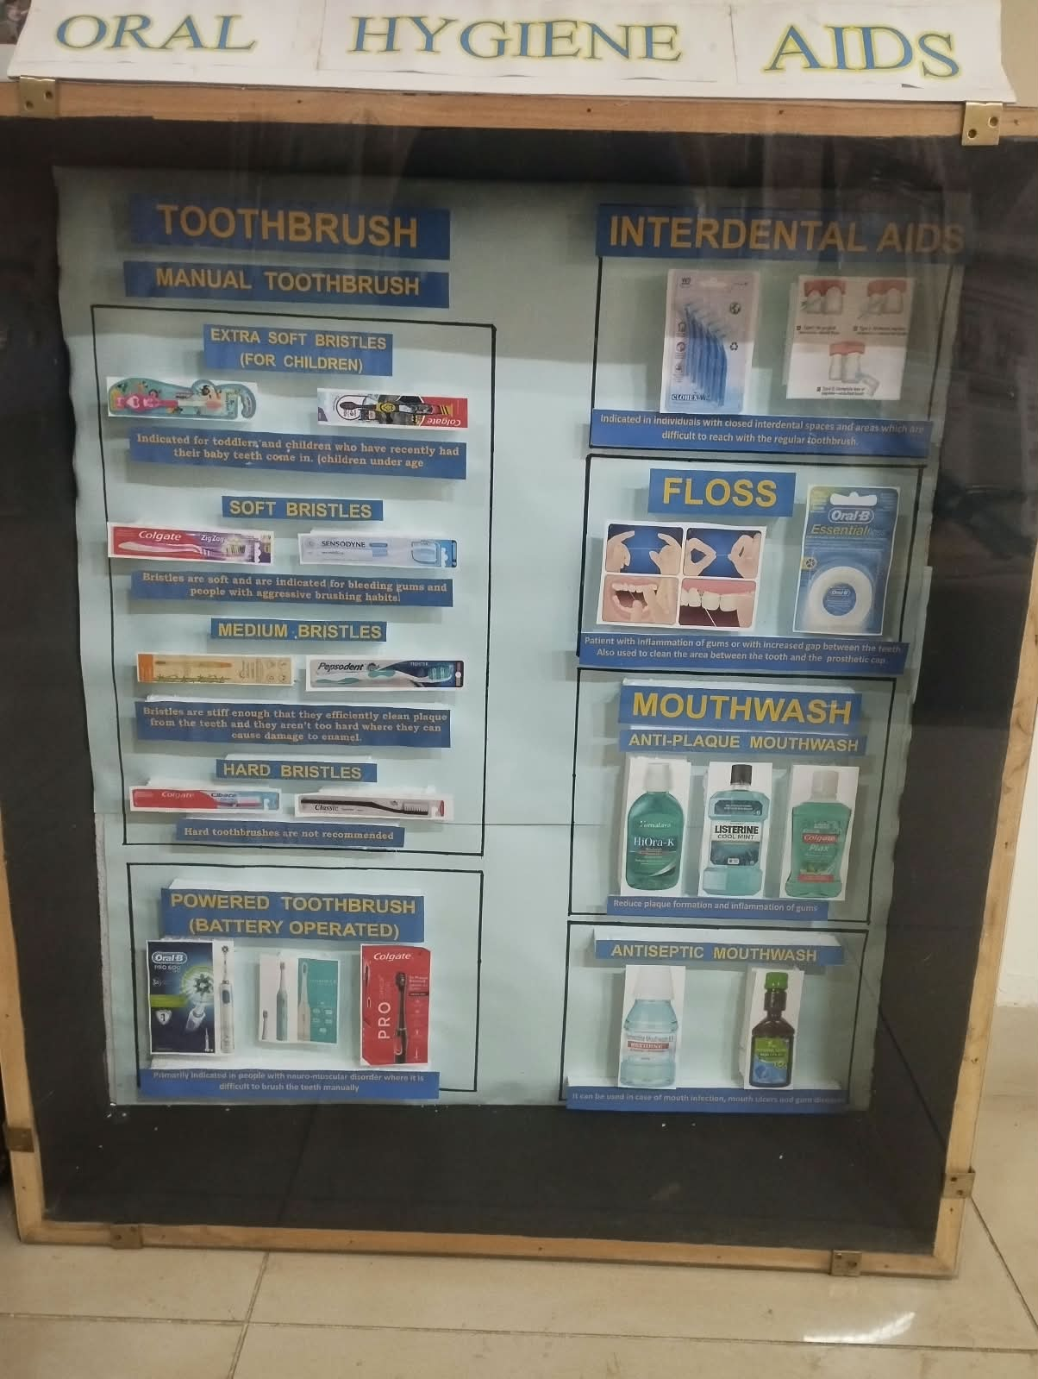 | 1. Displays commonly used aids for maintaining oral hygiene.  2. Helps learners understand the appropriate use of toothbrushes, floss and other cleaning aids.

